

**B-FOR-BARK**

**(Disease Recognition System)**

Jaiprakash Advani (1847229)

Koustabh Krishna (1847234)

Nithya V (1847245)

Under the guidance of

Dr. Nismon Rio R

A RDBMS project report submitted in partial fulfillment of the requirements for the award of degree of

Master of Computer Applications of CHRIST (Deemed to be University)

October - 2019



CERTIFICATE

*This is to certify that the report titled* ***B-FOR-BARK*** *is a bona fide record of work done by* ***Jaiprakash Advani (1847229), Koustabh Krishna (1847234) and Nithya V (1847245)*** *of CHRIST (Deemed to be University), Bangalore, in partial fulfillment of the requirements of III Semester MCA during the year 2019.*

**Head of the Department Project Guide**

Valued-by:

|  |  |  |
| --- | --- | --- |
|  | Examination Centre | : CHRIST  (Deemed to be University) |
| 1. |  |
| 2. | Date of Exam | : 30/08/2019 |

# ACKNOWLEDGEMENTS

### B-for-Bark would not have been possible without the support and guidance of experienced and knowledgeable members of the Department of Computer Science, CHRIST (Deemed to be University), Bengaluru.

### First, we would first like to thank Prof. Joy Paulose, Head of the Department, Department of Computer Science, CHRIST (Deemed to be University), for his endless support, and valuable feedback which has helped us constantly improve both our work processes and our overall project.

We would also like to thank our Coordinator, Prof. Tulasi B, for her encouragement and contributions that helped to facilitate the successful execution of this project.

We would like to express our gratitude to our Project Guide, Dr. Nismon Rio R, for his tireless guidance and innumerable inputs throughout the course of our project development. He helped orient us towards the right direction during each of our project’s phases.

We express our sincere thanks to Prof. Smitha Vinod, Dr. Chandra J and Prof. Arul Kumar lecturers of the Department of Computer Science, CHRIST (Deemed to be University), for their valuable suggestions during the course of this project. Their critical suggestions helped us to improve the project work.

We would like to extend our warmest gratitude to the faculty members of the Department of Computer Science, CHRIST (Deemed to be University), for their advice and motivation in helping us stay on track throughout development. We are also thankful to our peers from MSc Computer Science for their assistance and inputs throughout the development process. We thank everyone who has contributed and assisted us during the development of Green Homes both directly and indirectly.

**ABSTRACT**

The B-for-Bark is the Pet Health Web based System which is developed to ensure the Healthy life style of the pets on the regular schedule and to guarantee that pets are treated with love and care. This system ensures that the pet is driving a glad and Healthy life through different functionalities, if the pet is suffering from any disease, the proprietor of the pet can login to the system, and check the expected disease through the symptoms, consequently the natural remedies the dog require based on the disease will be generated and the Heath card is also provided for each and every pet. Based the Disease the Doctors are suggested and the Doctor gets the authorized entry to view the Health card of the pet and furthermore to modify the Health card if essential. User can consult a Doctor via system view the location details of the doctor and take an Appointment.

**TABLE OF CONTENTS**

|  |  |  |
| --- | --- | --- |
| **Sl. No.** | **Content** | **Page No.** |
| **1** | **Introduction** | **1** |
|  | 1.1 Overview of the system | 1 |
| **2** | **System analysis** | **2** |
|  | 2.1 Existing system | 2 |
|  | 2.1.1 Limitations of the existing system | 2 |
|  | 2.2 Proposed system | 2 |
|  | 2.2.1 Advantages of proposed system | 3 |
|  | 2.3 Literature survey | 3 |
|  | 2.4 Software tools used | 4 |
|  | 2.4.1 Front end | 4 |
|  | 2.4.1.1 Html | 4 |
|  | 2.4.1.2 Bootstrap | 5 |
|  | 2.4.1.3 JavaScript | 5 |
|  | 2.4.2 Backend | 6 |
|  | 2.4.2.1 Django 2.1 | 6 |
|  | 2.4.2.2 PostgreSQL | 7 |
|  | 2.5 Software used | 7 |
|  | 2.5.1 GitHub | 7 |
|  | 2.5.2 Sublime text / Visual studio code | 7 |
|  | 2.5.3 Pgadmin4 (PostgreSQL IDE) | 8 |
| **3** | **System Requirements** | **9** |
|  | 3.1 System model | 9 |
|  | 3.2 User Requirements | 9 |
|  | 3.2.1 Functional requirements | 9 |
|  | 3.2.1.1 Participant | 9 |
|  | 3.2.1.2 Sponsors | 9 |
|  | 3.2.1.3 Organizers | 10 |
|  | 3.2.1.4 Blog | 10 |
|  | 3.2.1.5 Community | 10 |
|  | 3.2.1.6 Resources | 10 |

|  |  |  |
| --- | --- | --- |
|  | 3.2.1.7 Query | 10 |
|  | 3.2.1.8 Accounts | 10 |
|  | 3.2.1.9 About us | 10 |
|  | 3.2.2 Non-Functional requirements | 11 |
|  | 3.3 System requirements | 11 |
|  | 3.3.1 Hardware requirements | 11 |
|  | 3.3.2 Software requirements | 11 |
|  | 3.3.2.1 Front end | 11 |
|  | 3.3.2.2 Back end | 12 |
|  | 3.3.2.3 Software used | 12 |
| **4** | **Design specification** | **13** |
|  | 4.1 Architectural design | 13 |
|  | 4.2 Data flow diagram | 14 |
|  | 4.2.1 Context diagram (Level 0 DFD) | 14 |
|  | 4.2.2 Level 1 DFD | 14 |
|  | 4.2.3 Level 2 DFD | 15 |
|  | 4.3 Entity relationship diagram | 15 |
|  | 4.4 Database design | 17 |
|  | 4.4.1 User | 17 |
|  | 4.4.2 User profile | 17 |
|  | 4.4.3 Blogs info | 18 |
|  | 4.4.4 Event location | 18 |
|  | 4.4.5 Event details | 19 |
|  | 4.4.6 Organize event | 19 |
|  | 4.4.7 Share resource | 20 |
|  | 4.4.8 Sponsorship | 20 |
|  | 4.4.9 Event feedback | 21 |
|  | 4.4.10 Participate event | 21 |
|  | 4.4.11 Sponsor transaction | 22 |
|  | 4.4.12 About Description | 22 |
|  | 4.4.13 Contact | 22 |
|  | 4.4.14 Our services | 23 |
|  | 4.4.15 Team info | 23 |

|  |  |  |
| --- | --- | --- |
|  | 4.4.16 Article | 23 |
|  | 4.4.17 Admin log | 24 |
|  | 4.4.18 Our partners | 24 |
|  | 4.4.19 Slider | 24 |
| **5** | **Implementation details** | **25** |
|  | 5.1 Source code | 25 |
|  | 5.1.1 TechEvent | 25 |
|  | 5.1.1.1 Settings.py | 25 |
|  | 5.1.1.2 Urls.py | 28 |
|  | 5.1.2 Accounts | 28 |
|  | 5.1.2.1 Models.py | 28 |
|  | 5.1.2.2 Urls.py | 29 |
|  | 5.1.2.3 Views.py | 29 |
|  | 5.1.2.4 Login.html | 31 |
|  | 5.1.3 Organizer | 38 |
|  | 5.1.3.1 Models.py | 38 |
|  | 5.1.3.2 Urls.py | 39 |
|  | 5.1.3.3 Views.py | 40 |
|  | 5.1.4 Sponsor | 55 |
|  | 5.1.4.1 Models.py | 55 |
|  | 5.1.4.2 Urls.py | 55 |
|  | 5.1.4.3 Views.py | 56 |
|  | 5.1.5 Participants | 61 |
|  | 5.1.5.1 Models.py | 61 |
|  | 5.1.5.2 Urls.py | 61 |
|  | 5.1.5.3 Views.py | 62 |
|  | 5.2 Screenshots | 68 |
|  | 5.2.1 Login and registration | 68 |
|  | 5.2.2 Our team and services | 68 |
|  | 5.2.3 Sponsors for event | 69 |
|  | 5.2.4 Participants for event | 69 |
|  | 5.2.5 Event details for participants | 69 |
|  | 5.2.6 Sponsored events | 70 |

|  |  |  |
| --- | --- | --- |
|  | 5.2.7 Participated events | 70 |
|  | 5.2.8 Upcoming Events | 70 |
|  | 5.2.9 Enquire about event | 71 |
|  | 5.2.10 Sponsor event | 71 |
|  | 5.2.11 Profile | 72 |
|  | 5.2.12 Write blogs | 72 |
|  | 5.2.13 Event venue | 73 |
|  | 5.2.14 Registered events | 73 |
|  | 5.2.15 Sponsorship details | 74 |
|  | 5.2.16 Share resources | 74 |
|  | 5.2.17 Enter event details | 75 |
|  | 5.2.18 Register event | 75 |
|  | 5.2.19 Organizer dashboard | 76 |
|  | 5.2.20 Blog details | 76 |
|  | 5.2.21 Admin Side | 77 |
|  | 5.2.22 Log Entries | 77 |
| **6** | **Testing** | **78** |
|  | 6.1 Test plan | 61 |
|  | 6.2 Test cases | 79 |
|  | 6.2.1 Login form | 79 |
|  | 6.2.2 Registration form | 80 |
|  | 6.2.3 Organize event form | 81 |
|  | 6.2.4 Organizer dashboard | 82 |
|  | 6.2.5 Your events | 82 |
|  | 6.2.6 Participate events | 82 |
|  | 6.2.7 Enquire about an event | 83 |
|  | 6.2.8 Project home page | 84 |
|  | 6.2.9 Participant dashboard | 84 |
|  | 6.2.10 Event feedback | 84 |
|  | 6.2.11 Blogs | 85 |
|  | 6.2.12 Contact Page | 85 |
|  | 6.2.13 Admin | 86 |
| **7** | **Conclusion** | **87** |
|  | 7.1 Future enhancement | 87 |
|  | References | 88 |

|  |  |  |
| --- | --- | --- |
| **Table No.** | **Table Name** | **Page No.** |
|  | **Design specification** | **13** |
| Table 4.1 | user | 17 |
| Table 4.2 | userprofile | 17 |
| Table 4.3 | blogs_info | 18 |
| Table 4.4 | eventlocation | 18 |
| Table 4.5 | event_details | 19 |
| Table 4.6 | organise_event | 19 |
| Table 4.7 | share_resource | 20 |
| Table 4.8 | sponsorship | 20 |
| Table 4.9 | event_feedback | 21 |
| Table 4.10 | participate_event | 21 |
| Table 4.11 | sponsor_transaction | 22 |
| Table 4.12 | about_description | 22 |
| Table 4.13 | contact | 22 |
| Table 4.14 | our_services | 23 |
| Table 4.15 | team_info | 23 |
| Table 4.16 | article | 23 |
| Table 4.17 | admin_log | 24 |
| Table 4.18 | our_partner | 24 |
| Table 4.19 | slider | 24 |
|  | **Testing** | **78** |
| Table 6.1 | Login test cases | 79 |
| Table 6.2 | Registration form test cases | 80 |
| Table 6.3 | Organize event form test cases | 81 |
| Table 6.4 | Organizer Dashboard test cases | 82 |
| Table 6.5 | Your events test cases | 82 |
| Table 6.6 | Participate events test cases | 82 |
| Table 6.7 | Enquire about an event test cases | 83 |
| Table 6.8 | Project home page test cases | 83 |
| Table 6.9 | Participant Dashboard test cases | 84 |
| Table 6.10 | Event feedback test cases | 84 |
| Table 6.11 | Blogs test cases | 84 |
| Table 6.12 | Contact page test cases | 85 |
| Table 6.13 | Admin test cases | 86 |

|  |  |  |
| --- | --- | --- |
| **Fig. No.** | **Figure Name** | **Page No.** |
|  | **System Requirements** | **9** |
| Fig. 3.1 | System model | 9 |
|  | **Design specification** | **13** |
| Fig. 4.1 | Project architecture | 13 |
| Fig. 4.2 | Level 0 DFD | 14 |
| Fig. 4.3 | Level 1 DFD | 14 |
| Fig. 4.4 | Level 2 DFD | 15 |
| Fig. 4.5 | ER Diagram | 16 |
|  | **Implementation details** | **25** |
| Fig. 5.1 | Login and registration | 68 |
| Fig. 5.2 | Our team and services | 68 |
| Fig. 5.3 | Sponsors for event | 69 |
| Fig. 5.4 | Participants for event | 69 |
| Fig. 5.5 | Event details for participants | 69 |
| Fig. 5.6 | Sponsored events | 70 |
| Fig. 5.7 | Participated events | 70 |
| Fig. 5.8 | Upcoming Events | 70 |
| Fig. 5.9 | Enquire about event | 71 |
| Fig. 5.10 | Sponsor event | 71 |
| Fig. 5.11 | Profile | 72 |
| Fig. 5.12 | Write blogs | 72 |
| Fig. 5.13 | Event venue | 73 |
| Fig. 5.14 | Registered events | 73 |
| Fig. 5.15 | Sponsorship details | 74 |
| Fig. 5.16 | Share resources | 74 |
| Fig. 5.17 | Enter event details | 75 |
| Fig. 5.18 | Register event | 75 |
| Fig. 5.19 | Organizer dashboard | 76 |
| Fig. 5.20 | Blog details | 76 |
| Fig. 5.21 | Admin Side | 77 |
| Fig. 5.22 | Log Entries | 77 |

1. **INTRODUCTION**

**1.1 OVERVIEW OF THE SYSTEM**

Disease management system is web-based application where one can search for diseases according to the symptoms provided. The audience for this system is huge as in today’s world every age group has easy access to internet and every other person is concerned about health of their loved pets.

In today’s world every person is concerned about their pet and especially dogs, they care for their pet like their own child and have a serious concern about the health of the pet. If something happens to our pet, we will not take rest until the pet is perfectly fit. The main targeted audience is the one who cannot reach to veterinarian easily. With this system, they can just log in and check whether the symptoms visible are something to be given importance or not. This system could save lives of pets if its accuracy is maximised and if it has a huge databank of diseases and its symptoms.

1. **SYSTEM ANALYSIS**
   1. **EXISTING SYSTEM**

System Name: PEDMD

PETMD is the largest global source of pet health information in the world today. It is a part of a global network of veterinary professionals; PETMD’s content was created by veterinarians for consumers and veterinarians. The content is written by veterinarians and approved by the veterinarian’s team. Hundreds of veterinarians, spanning eight countries across the world were consulted, interviewed and enlisted to write, verify, and approve the content.

# PETMD contains three basic functionalities:

# Search for pet health database

# Connect with a veterinarian and visit them often

# Discover new things that will inspire you to keep your pet healthy

* + 1. **LIMITATIONS OF THE EXISTING SYSTEM**
* Existing framework has a manual search, which is hard for client.
* The user can only get details of certain outcome as in they have to guess the actual disease and search for it on the system.
* This system cannot recognize any disease.
* Furthermore, there is no health card for each dog where the veterinarians can view the details related to the dogs whom they are currently treating and the previous history of the dog’s treatment.
  1. **PROPOSED SYSTEM**

**Disease recognition system for dogs** is web-based application where one can search for diseases related to dog according to the symptoms provided by the user. The audience for this system is huge as in today’s world every age group has easy access to internet and every other person is concerned about their pet’s health.

With this system, they can just log in and check whether the symptoms visible are something to be given importance or not. This system could save lives if its accuracy is maximized and if it has a huge databank of diseases and its symptoms.

* + 1. **ADVANTAGES OF PROPOSED SYSTEM**
* Our system automatically searches for the disease and gives the outcome, a recognition system. In the Existing framework, we have to manually search the details about the concerned disease, which is not feasible for the user in most of the occasions.
* Furthermore, we are additionally exhibiting the trend analysis about the searched disease with a graphical portrayal.
* In our system, we provide the user with the user-friendly interface which gives substantially better outcome in detail.
* With regard to Trend Analysis, we will be providing food for the month.
  1. **LITERATURE SURVEY**

Budimir Plavsic and Drago Nedic has proposed Veterinary information management system (VIMS) in the process of notification and management of animal disease .The role of information system in animal disease diagnosis, surveillance and notification, control of national and international trade of commodities, food safety management, investigation of diseases, predictive microbiology and quantitative risk assessment is of great importance for the quality of veterinary service. Integral part of the VIMS is animal disease notification system designed according to and in compliance with international requirements, standards and recommendation and able to exchange relevant information with similar information systems. Some external systems, such as a laboratory information system, will ensure better control of animal diseases, improved system functionality, especially in establishing the sanitary status of individual animals, flocks, zones and compartments or the whole country, as well as the control of the trading of animals and animal products. The introduction of information systems into the veterinary system would ensure availability of accurate and reliable data for expert analysis, but also needed for improvement of quality management in the food chain. This would influence decrease of the number of outbreak in animal’s life cycle [1].

* 1. **SOFTWARE TOOLS USED**
     1. **FRONT END**
        1. **HTML**

HTML stands for Hyper Text Markup Language and was intended to be used solely to provide document structure for a text-based communication medium. Hypertext Markup Language commonly referred to as HTML is the standard markup language used to create web pages. It is written in the form of HTML elements consisting of tags enclosed in angle brackets (like <html>). HTML tags most commonly come in pairs like <h1> and </h1>, although some tags represent empty elements and so are unpaired, for example <img>. The first tag in a pair is the start tag, and the second tag is the end tag (they are also called opening tags and closing tags). Web browsers can read HTML files and compose them into visible or audible web pages. Browsers do not display the HTML tags and scripts, but use them to interpret the content of the page. HTML describes the structure of a website semantically along with cues for presentation, making it a markup language, rather than a programming language. HTML elements form the building blocks of all websites. HTML allows images and objects to be embedded and can be used to create interactive forms. It provides a means to create structured documents by denoting structural semantics for text such as headings, paragraphs, lists, links, quotes and other items.

* + - 1. **BOOTSTRAP**

Bootstrap is a free and open-source CSS framework directed at responsive, mobile-first front-end web development. It contains CSS- and JavaScript-based design templates for typography, forms, buttons, navigation and other interface components. The Bootstrap framework is built on HTML, CSS, and JavaScript (JS) to facilitate the development of responsive, mobile-first sites and apps.

Bootstrap includes user interface components, layouts and JS tools along with the framework for implementation. The software is available precompiled or as source code. Bootstrap also comes with several JavaScript components in the form of jQuery plugins. They provide additional user interface elements such as dialog boxes, tooltips, and carousels. Each Bootstrap component consists of an HTML structure, CSS declarations, and in some cases accompanying JavaScript code. They also extend the functionality of some existing interface elements, including for example an auto- complete function for input fields.

* + - 1. **JAVASCRIPT**

JavaScript can function as both a procedural and an object-oriented language. Objects are created programmatically in JavaScript, by attaching methods and properties to otherwise empty objects at run time, as opposed to the syntactic class definitions common in compiled languages like C++ and Java. Once an object has been constructed, it can be used as a blueprint (or prototype) for creating similar objects. JavaScript's dynamic capabilities include runtime object construction, variable parameter lists, function variables, dynamic script creation (via eval introspection (via for ... in), and source code recovery (JavaScript programs can decompile function bodies back into their source text). JavaScript is also used in environments that are not Web-based, such as PDF documents, site-specific browsers, and desktop widgets. Newer and faster JavaScript virtual machines (VMs) and platforms built upon them have also increased the popularity of JavaScript for server- side Web applications. On the client side, JavaScript has been traditionally implemented as an interpreted language, but most recent browsers perform just-in-time compilation. It is also used in game development, the creation of desktop and mobile applications, and server-side network programming with run-time environments such as Node.js.

* + - 1. **CSS**

Cascading Style Sheets (CSS) is a style sheet language used for describing the presentation of a document written in a markup language like HTML. CSS is a cornerstone technology of the World Wide Web, alongside HTML and JavaScript.CSS is designed to enable the separation of presentation and content, including layout, colors, and fonts.[[3]](https://en.wikipedia.org/wiki/Cascading_Style_Sheets#cite_note-3) This separation can improve content accessibility, provide more flexibility and control in the specification of presentation characteristics, enable multiple web pages to share formatting by specifying the relevant CSS in a separate .css file, and reduce complexity and repetition in the structural content. Separation of formatting and content also makes it feasible to present the same markup page in different styles for different rendering methods, such as on-screen, in print, by voice (via speech-based browser or screen reader), and on Braille-based tactile devices. CSS also has rules for alternate formatting if the content is accessed on a mobile device.

* + - 1. **PHP**

PHP: Hypertext Preprocessor (or simply PHP) is a general-purpose programming language originally designed for web development. It was originally created by Rasmus Lerdorf in 1994; the PHP reference implementation is now produced by The PHP Group.[[7]](https://en.wikipedia.org/wiki/PHP#cite_note-about_PHP-7) PHP originally stood for *Personal Home Page*, but it now stands for the [recursive initialism](https://en.wikipedia.org/wiki/Recursive_initialism) *PHP: Hypertext Preprocessor.* PHP code may be executed with a [command line interface](https://en.wikipedia.org/wiki/Command-line_interface) (CLI), embedded into [HTML](https://en.wikipedia.org/wiki/HTML) code, or used in combination with various [web template systems](https://en.wikipedia.org/wiki/Web_template_system), web [content management systems](https://en.wikipedia.org/wiki/Content_management_system), and [web frameworks](https://en.wikipedia.org/wiki/Web_framework). PHP code is usually processed by a PHP interpreter implemented as a [module](https://en.wikipedia.org/wiki/Plugin_(computing)) in a web server or as a [Common Gateway Interface](https://en.wikipedia.org/wiki/Common_Gateway_Interface) (CGI) executable. The web server outputs the results of the interpreted and executed PHP code, which may be any type of data, such as generated HTML code or binary image data. PHP can be used for many programming tasks outside of the web context, such as standalone graphical applications and robotic [drone](https://en.wikipedia.org/wiki/Unmanned_aerial_vehicle) control.

* + 1. **BACK END**
       1. **MYSQL**

MySQL is free and open-source software under the terms of the [GNU General Public License](https://en.wikipedia.org/wiki/GNU_General_Public_License), and is also available under a variety of [proprietary](https://en.wikipedia.org/wiki/Proprietary_software) licenses. MySQL was owned and sponsored by the [Swedish](https://en.wikipedia.org/wiki/Sweden) company [MySQL AB](https://en.wikipedia.org/wiki/MySQL_AB), which was bought by [Sun Microsystems](https://en.wikipedia.org/wiki/Sun_Microsystems) (now [Oracle Corporation](https://en.wikipedia.org/wiki/Oracle_Corporation)).[[8]](https://en.wikipedia.org/wiki/MySQL#cite_note-sunacquire-8) In 2010, when Oracle acquired Sun, Widenius [forked](https://en.wikipedia.org/wiki/Fork_(software_development)) the [open-source](https://en.wikipedia.org/wiki/Open-source) MySQL project to create [MariaDB](https://en.wikipedia.org/wiki/MariaDB).

MySQL is a component of the [LAMP](https://en.wikipedia.org/wiki/LAMP_(software_bundle)) [web application](https://en.wikipedia.org/wiki/Web_application) [software stack](https://en.wikipedia.org/wiki/Software_stack) (and [others](https://en.wikipedia.org/wiki/List_of_AMP_packages)), which is an acronym for [*Linux*](https://en.wikipedia.org/wiki/Linux)*,*[*Apache*](https://en.wikipedia.org/wiki/Apache_HTTP_Server)*, MySQL,*[*Perl*](https://en.wikipedia.org/wiki/Perl)*/*[*PHP*](https://en.wikipedia.org/wiki/PHP)*/*[*Python*](https://en.wikipedia.org/wiki/Python_(programming_language)). MySQL is used by many database-driven web applications, including [Drupal](https://en.wikipedia.org/wiki/Drupal), [Joomla](https://en.wikipedia.org/wiki/Joomla), [phpBB](https://en.wikipedia.org/wiki/PhpBB), and WordPress. MySQL is also used by many popular [websites](https://en.wikipedia.org/wiki/Website), including [Facebook](https://en.wikipedia.org/wiki/Facebook), [Flickr](https://en.wikipedia.org/wiki/Flickr), [MediaWiki](https://en.wikipedia.org/wiki/MediaWiki), [Twitter](https://en.wikipedia.org/wiki/Twitter), and YouTube.

* 1. **SOFTWARE USED**
     1. **GITHUB**

GitHub is a website and cloud-based service that helps developers store and manage their code, as well as track and control changes to their code. GitHub is a for-profit company that offers a cloud-based Git repository hosting service. Essentially, it makes it a lot easier for individuals and teams to use Git for version control and collaboration.

GitHub’s interface is user-friendly enough so even novice coders can take advantage of Git. Without GitHub using Git generally requires a bit more technical savvy and use of the command line. GitHub have helped us to collaborate with each other and to synchronize and smooth way at the time of developing, integrating the projects modules.

* + 1. **WAMPSERVER**

WampServer refers to a software stack for the Microsoft Windows operating system, created by Romain Bourdon and consisting of the Apache web server, OpenSSL for SSL support, MySQL database and PHP programming language.

The most important part of the WAMP package is Apache (or "Apache HTTP Server") which is used run the web server within Windows. By running a local Apache web server on a Windows machine, a web developer can test webpages in a web browser without publishing them live on the Internet.

WAMP also includes MySQL and PHP, which are two of the most common technologies used for creating dynamic websites. MySQL is a high-speed database, while PHP is a scripting language that can be used to access data from the database. By installing these two components locally, a developer can build and test a dynamic website before publishing it to a public web server.

While Apache, MySQL, and PHP are open source components that can be installed individually, they are usually installed together. One popular package is called "WampServer," which provides a user-friendly way to install and configure the "AMP" components on Windows.

* + 1. **BRACKETS / VISUAL STUDIO CODE**

Brackets or Visual Studio code are text editors with a Python application-programming interface (API). It natively supports many programming languages and markup languages, and functions can be added by users with plugins.

There are many features that allows users to select entire columns at once or place more than one cursor in text, which allows for simultaneous editing. All cursors then behave as if each of them was the only one in the text. Commands like move by character, move by line, text selection, move by words, move by sub words, move to beginning/end of line, etc. Affect all cursors independently, allowing one to edit slightly complex repetitive structures quickly without the need to use macros or regex.

Brackets and Visual studio code will offer to complete entries as the user is typing depending on the language being used. It also auto-completes variables created by the user. The dark background is intended to reduce eyestrain and increase the amount of contrast with the text. Syntax highlighting also makes syntaxes of the language easier to read. These editors allow users to run code for certain languages from within the editor, which eliminates the need to switch out to the command line and back again. This function can also be set to build the code automatically every time the file is saved.

1. **SYSTEM REQUIREMENTS**
   1. **SYSTEM MODEL**

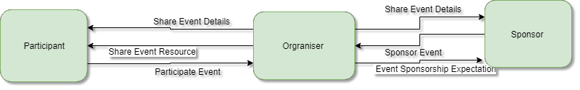

**Fig. 3.1 System Model**

The project has three main users the participant, organizer and Sponsors of any events like Hackathon, It Fest, Conference, Seminars and so on. The organizer creates the event and share the event details and resources with the participants, the interested participants register in the events and take part in the events. The sponsors who get the event details and sponsorship details and choose to sponsor the event seeing the facilities provided. The entire project focuses on providing a common platform to share the event details and posters, the registration platform, and the other functionalities like the blog and resource sharing. Each event organizer needs to create their own website or platform to share resources and such things. This system will help the organizers to market their event and can quickly find the sponsors for the event.

* 1. **USER REQUIREMENTS**
     1. **FUNCTIONAL REQUIREMENTS**
        1. **DISEASE SEARCH**
* INPUT: Symptoms (multiple inputs can be given)

OUTPUT: The most relevant disease name predicted. Its quick remedies (if any), all symptoms and available doctors. Search ID and Disease ID.

* User can Search for the Disease directly and view the symptoms for the same disease and can view the natural remedies for the same disease, and the suggested Doctor for the same disease.
  + - 1. **SYMPTOMS SEARCH**
* INPUT: Disease name.

OUTPUT: List of the symptoms of the disease, quick remedies (if any) and available doctors for it. Disease ID, Search ID

* User can also Search for the Symptoms and view the multiple diseases expected. And appropriate disease description for the symptoms can view the complete description of the disease through the website suggested.
  + - 1. **SEARCH ANALYSIS / TREND ANALYSIS**
* INPUT: from and to dates.

OUTPUT: Most browsed diseases and symptoms.

* By considering the previous to the current date, the most searched diseases are taken and the trend analysis page is constructed.
  + - 1. **PET REGISTER**
* INPUT: Pet name, Breed, Blood group, Age, Weight, allergies, previously diagnosed diseases…

OUTPUT: The health card (which will contain all the details of the pet) along with the pet ID.

* By taking the following details, the pet registration is done with all the required validation. After this, the Health card will be generated for the pet that is being registered successfully.
  + - 1. **USER REGISTRATION**
* **INPUT:** User id**,** Password, Name, E-mail, Phone Number, State, City, Street.

**OUTPUT**: User will be registered successfully.

* By taking the above details, the user registration is done with all the required validation. After the registration, the user can access the system benefits.
  + - 1. **CONTACT**
* INPUT: Health card, Disease name and symptoms

OUTPUT: Appointment details and location.

* The doctor is Suggested based on the category of the pet disease and the appointment can be taken with the Doctor and the user can view the location of the doctor. Through which the Doctor gets the Authority to view the Health card details of the pet.
  + - 1. **DOCTOR LOGIN**
* INPUT: User id**,** Password,

OUTPUT: successfully Sign-in.

* The certified doctor are Already added to the list in the database and they can directly login with the given username and password.
  + - 1. **VIEW HEALTHCARD**
* INPUT: Pet ID

OUTPUT: Health Card

* The certified doctor can view the Health card of the pet and even Allowed to modify the health card if necessary.
  + 1. **NON-FUNCTIONAL REQUIREMENTS**
       1. **HARDWARE REQUIREMENTS**
* 1 GB RAM
* 1.5GB HDD
* Windows XP
  + - 1. **SOFTWARE REQUIREMENTS**

The below are the specific software requirements for the system to run successfully.

* **FRONT END**
  + HTML
  + CSS
  + PHP
  + BOOTSTRAP
  + JAVASCRIPT
    - 1. **BACK END**
  + MYSQL
    - 1. **SOFTWARE USED**
  + GITHUB DESKTOP
  + BRACKETS / VISUAL STUDIO CODE
  + WAMP SERVER

1. **DESIGN SPECIFICATION**
   1. **ARCHITECTURAL DESIGN**

Django is a Python-based free and open-source web framework, which follows the model-template-view (MTV) architectural pattern It is maintained by the Django Software Foundation (DSF), an independent organization established as a non-profit.

Django's primary goal is to ease the creation of complex, database-driven websites. The framework emphasizes reusability and "pluggability" of components, less code, low coupling, rapid development, and the principle of don't repeat yourself. Python is used throughout, even for settings files and data models. Django also provides an optional administrative create, read, update and delete interface that is generated dynamically through introspection and configured via admin models.

The project architecture is in such a way that when a user sends a URL GET request we send it our application URLs and look for the same pattern of URL we have received and if that URL matches we sends the request to views where we perform the required action as per the request and if it is required to send the data to the database we access model of the required table and store or retrieve the response through templates.

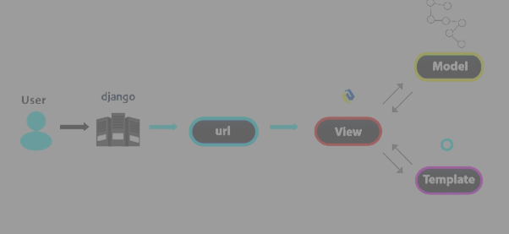

**Fig. 4.1 Project architecture**

* 1. **DATA FLOW DIAGRAM**

The context diagram also called as the Level 1 DFD (Fig 4.2 level 0 DFD) depicts the overall data flow in the system. The Figure (Fig 4.3 level 1 DFD) depicts the operations on the system and the more detailed details of the data flow has been included in the Figure (Fig 4.4 level 2 DFD). These figures constitute the data flow representation in the system.

* + 1. **CONTEXT DIAGRAM (LEVEL 0 DFD)**

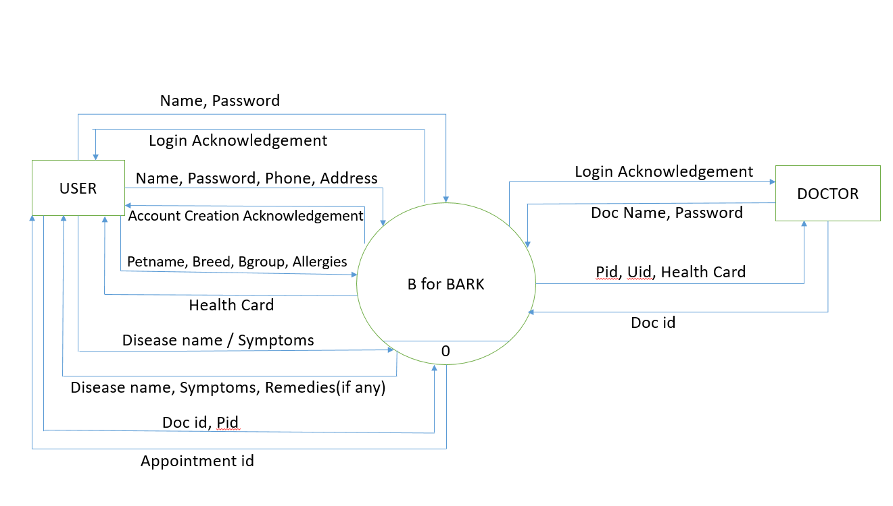

**Fig. 4.2 level 0 DFD**

* + 1. **LEVEL 1 DFD**

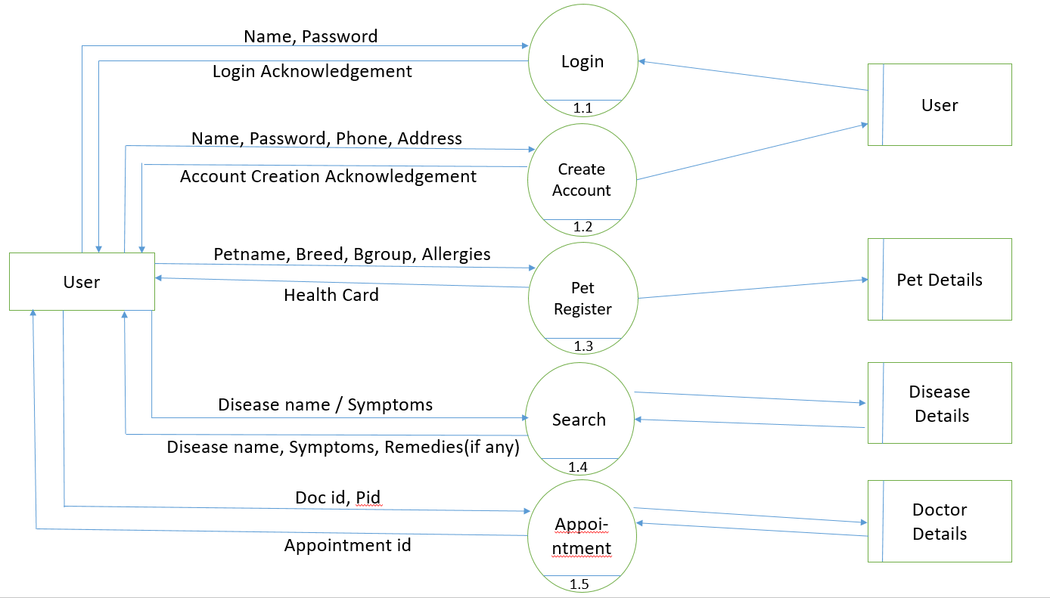

**Fig. 4.3 level 1 DFD**

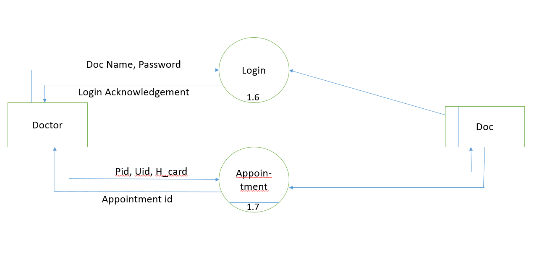

**Fig 4.4 level 1 DFD**

* 1. **ENTITY RELATIONSHIP DIAGRAM**

The entity relationship diagram describes interrelated things in the project. A basic ER model is composed of entity types and specifies relationships that can exist between instances of those entity types. An entity relationship diagram shows the relationships of entity sets stored in a database. An entity in this context is an object, a component of data. An entity set is a collection of similar entities. These entities can have attributes that define its properties.

The entity relationship diagram (Fig. 4.5 ER Diagram), represents the inter relativity of the different project components and how it is related together. the different modules of the project. the entity relationship diagram helps in the design and development of the database.

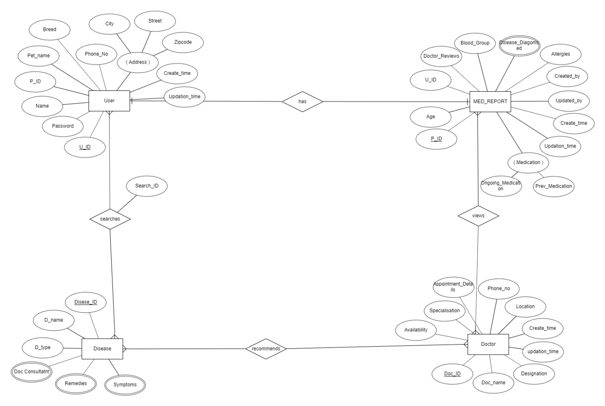

**Fig. 4.5 ER Diagram**

* 1. **DATABASE DESIGN**
     1. **USER_DETAILS**

Table 4.1 user_details

|  |  |  |  |
| --- | --- | --- | --- |
| **Attribute Name** | **Data Type** | **Constraints** | **Description** |
| U_Id | integer | Primary Key | identify each user |
| Password | character varying (20) | Not Null | stores password |
| Name | character varying (50) | Not Null | Stores name |
| Email | character varying (50) | Not Null | Stores Email |
| Phone | bigint(10) | Not Null | Stores Phone |
| Street | longtext | Not Null | Stores Street |
| City | longtext | Not Null | Stores city |
| State | longtext | Not Null | Stores State |

* + 1. **USER_PET**

Table 4.2 user_pet

|  |  |  |  |
| --- | --- | --- | --- |
| **Attribute Name** | **Data Type** | **Constraints** | **Description** |
| P_Id | integer | Primary Key | ID of the table |
| Name | character varying (50) | Foreign Key | User Name |

* + 1. **PET_DETAILS**

Table 4.3 pet_details

|  |  |  |  |
| --- | --- | --- | --- |
| **Attribute Name** | **Data Type** | **Constraints** | **Description** |
| P_Id | integer | Primary Key | ID of the table |
| Name | character varying (30) | Not Null | Pet Name |
| Breed | character varying (30) | Not Null | Breed |
| Blood_group | character varying (10) | Not Null | Blood group of Pet |
| Age | integer | Not Null | Age |
| Weight | integer | Not Null | Weight |

* + 1. **PET_ALLERGIES**

Table 4.4 pet_allergies

|  |  |  |  |
| --- | --- | --- | --- |
| **Attribute Name** | **Data Type** | **Constraints** | **Description** |
| P_Id | integer | Foreign Key | ID of the table |
| Allergies | character varying (30) | Not Null | Allergies of Pet |

* + 1. **PET_MEDIC**

Table 4.5 pet_medic

|  |  |  |  |
| --- | --- | --- | --- |
| **Attribute Name** | **Data Type** | **Constraints** | **Description** |
| P_Id | integer | Foreign Key | ID of the table |
| Medication | character varying (30) | Not Null | Medications of Pet |

* + 1. **PET_APPOINTMENT**

Table 4.6 pet_appointment

|  |  |  |  |
| --- | --- | --- | --- |
| **Attribute Name** | **Data Type** | **Constraints** | **Description** |
| U_Id | integer | Foreign Key | User Id |
| P_Id | integer | Foreign Key | Pet Id |

* + 1. **REMEDIES**

Table 4.7 remedies

|  |  |  |  |
| --- | --- | --- | --- |
| **Attribute Name** | **Data Type** | **Constraints** | **Description** |
| Disease_Id | integer | Foreign Key | Disease Id |
| Remedies | longtext | Not Null | Remedies for Disease |

* + 1. **SYMPTOMS**

Table 4.8 symptoms

|  |  |  |  |
| --- | --- | --- | --- |
| **Attribute Name** | **Data Type** | **Constraints** | **Description** |
| Disease_Id | integer | Foreign Key | Disease Id |
| Symptoms | longtext | Not Null | Symptoms for Disease |

* + 1. **DISEASE_DETAILS**

Table 4.9 disease_details

|  |  |  |  |
| --- | --- | --- | --- |
| **Attribute Name** | **Data Type** | **Constraints** | **Description** |
| Disease_id | integer | Primary Key | ID of the table |
| Disease_name | character varying (50) | Not Null | Disease name |
| Disease_type | character varying (50) | Not Null | Disease type |
| Disease_description | longtext | Not Null | Description |

* + 1. **DOCTOR_CONSULTANT**

Table 4.10 doctor_consultant

|  |  |  |  |
| --- | --- | --- | --- |
| **Attribute Name** | **Data Type** | **Constraints** | **Description** |
| Disease_Id | integer | Foreign Key | Disease Id |
| Doc_consultant | character varying (30) | Not Null | Doctor name |

* + 1. **DOCTOR_DETAILS**

Table 4.11 doctor_details

|  |  |  |  |
| --- | --- | --- | --- |
| **Attribute Name** | **Data Type** | **Constraints** | **Description** |
| D_Id | integer | Primary Key | identify each Doctor |
| Password | character varying (30) | Not Null | stores Password |
| Doc_name | character varying (30) | Not Null | Stores Name |
| Speciality | character varying (30) | Not Null | Stores Speciality |
| Location | character varying (30) | Not Null | Stores Location |
| Phone | integer | Not Null | Stores Phone |

* + 1. **DOC_APPOINTMENT**

Table 4.12 doc_appointment

|  |  |  |  |
| --- | --- | --- | --- |
| **Attribute Name** | **Data Type** | **Constraints** | **Description** |
| Appointment_id | integer | Primary Key | ID of the table |
| Doc_Id | integer | Foreign Key | Doctor id |
| Pet_Id | integer | Foreign Key | Pet id |

* + 1. **D_SEARCH**

Table 4.13 d_search

|  |  |  |  |
| --- | --- | --- | --- |
| **Attribute Name** | **Data Type** | **Constraints** | **Description** |
| U_Id | integer | Foreign Key | Identify each User |
| Disease_Id | integer | Foreign Key | Identify Disease |
| Date | timestamp | Not Null | Stores Date |
| Search_Id | integer | Foreign Key | Identify the search |

# IMPLEMENTATION DETAILS

## SOURCE CODE

* + 1. **User**
       1. **Index.php**

<!--File description-->

<!--

File name:B for bark

Date:21/6/19

-->

<!DOCTYPE html>

<html lang="en">

<head>

<meta charset="utf-8">

<meta name="viewport" content="width=device-width, initial-scale=1">

<title>Disease Recognition System</title>

<link rel="stylesheet" href="bootstrap-4.1.3-dist/css/bootstrap.min.css">

<link rel="stylesheet" href="style.css">

<link rel="stylesheet" href="css/fixed.css">

<link rel="stylesheet" href="https://cdnjs.cloudflare.com/ajax/libs/animate.css/3.7.2/animate.min.css">

</head>

<body data-spy="scroll" data-target="#navbarResponsive">

</button>

<div class="collapse navbar-collapse" id="navbarResponsive">

<ul class="navbar-nav ml-auto">

<li class="nav-item">

<a class="nav-link" href="#home">Home</a>

</li>

<li class="nav-item">

<a class="nav-link" href="#features">Features</a>

</li>

<li class="nav-item">

<a class="nav-link" href="#resources">Services</a>

</li>

<li class="nav-item">

<a class="nav-link" href="#clients">Quotes</a>

</li>

<li class="nav-item">

<a class="nav-link" href="#contacts">Contacts</a>

</li>

<li class="nav-item">

<a class="nav-link" href="doctorlogin.php">Doctor</a>

</li>

<li class="nav-item">

<a class="nav-link" href="login.php">Sign-in</a>

</li>

<li class="nav-item">

<a class="nav-link" href="UserRegistration.php">Sign-up</a>

</li>

<!--<li class="nav-item">

<a class="nav-link" href="">Logout</a>

</li>-->

</ul>

</div>

</nav>

<!-- end vavigation-->

<!-- start Landing page section-->

<div class="landing">

<div class="home-wrap">

<div class="home-inner">

</div>

</div>

</div>

<div class="caption text-center">

<h1 class="animated bounceInRight delay-2s">Welcome to <span style="color:#1ebba3;"> B for Bark</span></h1>

<h3 class="animated heartBeat delay-2s">The Only Pet Health centre</h3>

<a class="btn btn-outline-light btn-lg" href="#course">Get Started</a>

</div>

<!-- end landing page-->

</div>

<!-- end home section-->

<!-- course section-->

<div id="course" class="offset">

<div class="col-12 narrow text-center">

<h1>We know your concern for pets.</h1>

<p class="lead">The dogs should be friendly,outgoing,healthy,well-groomed and love to be fussed. All breeds, crossbreeds, shapes and sizes are welcome.</p>

<a class="btn btn-secondary btn-md" href="" target="_blank">B for Bark</a>

</div>

</div>

<!-- end course section-->

<!-- features section-->

<div id="features" class="offset">

<!-- start jumbotron-->

<div class="jumbotron">

<div class="narrow text-center">

<div class="col-12">

<h3 class="heading">Features</h3>

<div class="heading-underline"></div>

</div>

<div class="row text-center">

<div class="col-md-4">

<div class="feature">

<i class="fas fa-play-circle fa-4x" data-fa-transform="shrink-3 up-5"></i>

<h3>Trend Analysis</h3>

<p>Recent Trends of the Dog Diseases.</p>

</div>

</div>

<div class="col-md-4">

<div class="feature">

<i class="fas fa-sliders-h fa-4x" data-fa-transform="shrink-4.5 up-4.5"></i>

<h3>Availability</h3>

<p>Availability of the Doctor Timings.</p>

</div>

</div>

<div class="col-md-4">

<div class="feature">

<i class="fab fa-wpforms fa-4x" data-fa-transform="shrink-4.5 up-4.5"></i>

<h3>Health card</h3>

<p>We provide the Health card for your pet.</p>

</div>

</div>

</div>

<!---- end row------>

</div>

<!-- end narrow-->

</div>

<!-- end jumbotron-->

</div>

<!-- end Features section-->

<!-- Resources section-->

<div id="resources" class="offset">

<div class="fixed-background">

<div class="row dark text-center">

<div class="col-12">

<h3 class="heading">Built with care</h3>

<div class="heading-underline"></div>

</div>

<div class="col-md-4">

<h3>HELP</h3>

<div class="feature">

<i class="fab fa-hire-a-helper fa-3x"></i>

</div>

<p class="lead">We Help you to keep your pet Healthy</p>

</div>

<div class="col-md-4">

<h3>BRING</h3>

<div class="feature">

<i class="fas fa-bold fa-3x"></i>

</div>

<p class="lead">We Bring you the best services Available</p>

</div>

<div class="col-md-4">

<h3>CARE</h3>

<div class="feature">

<i class="fab fa-cuttlefish fa-3x"></i>

<!-- font awesome icon-->

</div>

<p class="lead">We care and love your pets as ours.</p>

</div>

</div>

<!----end row dark--->

<div class="fixed-wrap">

<div class="fixed">

</div>

</div>

</div>

<!----end fixed background--->

<script type="text/javascript">

var vsid = "sa33363";

(function() {

var vsjs = document.createElement('script'); vsjs.type = 'text/javascript'; vsjs.async = true; vsjs.setAttribute('defer', 'defer');

vsjs.src = ('https:' == document.location.protocol ? 'https://' : 'http://') + 'www.virtualspirits.com/vsa/chat-'+vsid+'.js';

var s = document.getElementsByTagName('script')[0]; s.parentNode.insertBefore(vsjs, s);

})();

</script>

</body>

</html>

## Login.php

<!--File description-->

<!--

File name:B for bark

Date:21/6/19

-->

<!DOCTYPE html>

<html>

<head>

<meta charset="utf-8">

<meta name="viewport" content="width=device-width, initial-scale=1">

<title> Login</title>

<link rel="stylesheet" href="bootstrap-4.1.3-dist/css/bootstrap.min.css">

<link rel="stylesheet" href="style.css">

<link rel="stylesheet" href="css/fixed.css">

<style>

body {

margin: 0;

padding: 0;

font-family: sans-serif;

background-size: cover;

background-image: url(img/19.jpg);

max-width: 100%;

max-height: 100%;

}

.login-box {

width: 500px;

position: absolute;

background-color: white;

opacity: 0.8;

top: 50%;

left: 50%;

transform: translate(-50%, -50%);

color: black;

}

</style>

</head>

<body data-spy="scroll" data-target="#navbarResponsive">

<!-- home section-->

<div id="home">

<!-- navigation-->

<div id="home">

<!-- navigation-->

<nav class="navbar navbar-expand-md navbar-dark bg-dark fixed-top ">

<a class="navbar-brand" href="index.php"><img src="img/abc_new.png"></a>

<a class="nav-link" href="login.php">Sign-in</a>

</li>

<li class="nav-item">

<a class="nav-link" href="UserRegistration.php">Sign-up</a>

</li>

</ul>

</div>

</nav>

</div>

<div class="col-12 narrow text-center login-box">

<form action="login1.php" method="post">

<h1>Sign-in</h1>

<div class="textbox">

<!-- <i class="fas fa-user fa-3x " aria-hidden="true"></i>-->

<input type="text" placeholder="Username" name="Name" value="" required>

</div>

<div class="textbox">

<!-- <i class="fas fa-lock fa-3x" aria-hidden="true"></i>-->

<input type="password" placeholder="Password" name="Password" required value="">

</div>

<label>

<input type="checkbox" checked="checked" name="remember"> Remember me

</label>&nbsp;&nbsp;&nbsp;&nbsp;&nbsp;&nbsp;&nbsp;&nbsp;&nbsp;&nbsp;&nbsp;&nbsp;

<span class="psw">New <a href="UserRegistration.php">User</a></span>

<br>

<br>

<button class="btn btn-secondary btn-md" href="search.php" target="_blank" name="Login">Sign-in</button>

<div class="text-center p-t-12">

<span class="txt1">

Forgot

</span>

<a class="txt2" href="forgotPass.php">

Password

</a>

User Registration

<?php

include 'conn_file.php';

if(isset($_POST['Signup']))

{

$Pass=$_POST['Password'];

$Name=$_POST['Name'];

$Email=$_POST['Email'];

$Phone=$_POST['Phone'];

$Street=$_POST['Street'];

$City=$_POST['City'];

$State=$_POST['State'];

$sqlp1="SELECT * FROM user_details WHERE Name='$Name' and Password='$Pass'";

$resultp1=mysqli_query($conn,$sqlp1);

$count1=mysqli_num_rows($resultp1);

// echo $count1;

if($count1>0)

{

echo "<script language=\"JavaScript\">\n";

echo "alert('Username already exists.');\n";

echo "window.location='UserRegistration.php.'";

echo "</script>";

}

else

{

$qry="insert into user_details (Password,Name,Email,Phone,Street,City,State) values('$Pass','$Name','$Email','$Phone','$Street','$City','$State')";

$ret=mysqli_query($conn,$qry);

if($ret)

{

echo "<script language=\"JavaScript\">\n";

echo "alert('User Successfully Registered! You will be now redircted to Login Page');\n";

echo "window.location='login.php.'";

echo "</script>";

// exit;

}

else

{

die("ERROR ".mysqli_error($conn));

}

/*header("Location: search.php");// to user homepage */

}

}

?>

<!DOCTYPE html>

<html>

<?php include 'conn_file.php';?>

<head>

<meta charset="utf-8">

<meta name="viewport" content="width=device-width, initial-scale=1">

<title>UserRegistration</title>

<link rel="stylesheet" href="bootstrap-4.1.3-dist/css/bootstrap.min.css">

<link rel="stylesheet" href="style.css">

<link rel="stylesheet" href="css/fixed.css">

<style>

body {

margin: 0;

padding: 0;

font-family: sans-serif;

background-size: cover;

background-image: url("img/16.jpg");

max-width: 100%;

max-height: 100%;

}

.login-box {

width: 500px;

position: absolute;

background-color: white;

opacity: 0.8;

top: 50%;

left: 50%;

transform: translate(-50%, -50%);

color: black;

}

.login-box h1 {

float: left;

font-size: 40px;

border-bottom: 6px solid #1ebba3;

margin-bottom: 50px;

padding: 13px 0;

border-radius: 2px;

}

.textbox {

width: 100%;

overflow: hidden;

font-size: 20px;

padding: 8px 0;

margin: 8px 0;

border-bottom: 1px solid #1ebba3;

}

.textbox i {

width: 60px;

float: left;

text-align: center;

}

.textbox input {

border: none;

outline: none;

background: none;

color: black;

font-size: 18px;

width: 300px;

float: left;

margin: 0 10px;

}

.btn {

width: 100%;

background: none;

border: 2px solid #1ebba3;

color: black;

padding: 5px;

font-size: 18px;

cursor: pointer;

margin: 12px 0;

}

</style>

</head>

<body data-spy="scroll" data-target="#navbarResponsive">

<!-- home section-->

<div id="home">

<!-- navigation-->

<nav class="navbar navbar-expand-md navbar-dark bg-dark fixed-top ">

<a class="navbar-brand" href="index.php"><img src="img/abc_new.png"></a>

<button class="navbar-toggler" type="button" data-toggle="collapse" data-target="#navbarResponsive">

<span class="navbar-toggler-icon"></span>

</button>

<div class="collapse navbar-collapse" id="navbarResponsive">

<ul class ="navbar-nav ml-auto">

<li class="nav-item">

<a class= "nav-link" href="index.php">Home</a>

</li>

<!--

<li class="nav-item">

<a class="nav-link" href="#features">Features</a>

</li>

<li class="nav-item">

<a class="nav-link" href="#resources">Services</a>

</li>

<li class="nav-item">

<a class="nav-link" href="#clients">Quotes</a>

</li>

<li class="nav-item">

<a class="nav-link" href="#contacts">Contacts</a>

</li>

-->

<li class="nav-item">

<a class="nav-link" href="login.php">Sign-in</a>

</li>

<li class="nav-item">

<a class="nav-link" shref="UserRegistration.php">Sign-up</a>

</li>

</ul>

</div>

</nav>

</div>

<!-- end vavigation-->

<div class="col-12 narrow text-center login-box">

<form action="#" method="post">

<h1>Sign-Up</h1>

<div class ="textbox">

<!-- <i class="fas fa-user fa-3x " aria-hidden="true"></i>-->

<input type="text" placeholder="Username" name="Name" value="" required>

</div>

<div class ="textbox">

<!-- <i class="fas fa-user fa-3x " aria-hidden="true"></i>-->

<input type= "email" placeholder="Email" name="Email" pattern="[a-z0-9._%+-]+@[a-z0-9.-]+\.[a-z]{2, 3}$" title="Please input a valid format for email." required value="">

</div>

<div class ="textbox">

</div>

</body>

</html>

* + - 1. **User Register**

<?php

include 'conn_file.php';

if(isset($_POST['Signup']))

{

$Pass=$_POST['Password'];

$Name=$_POST['Name'];

$Email=$_POST['Email'];

$Phone=$_POST['Phone'];

$Street=$_POST['Street'];

$City=$_POST['City'];

$State=$_POST['State'];

$sqlp1="SELECT * FROM user_details WHERE Name='$Name' and Password='$Pass'";

$resultp1=mysqli_query($conn,$sqlp1);

$count1=mysqli_num_rows($resultp1);

// echo $count1;

if($count1>0)

{

echo "<script language=\"JavaScript\">\n";

echo "alert('Username already exists.');\n";

echo "window.location='UserRegistration.php.'";

echo "</script>";

}

else

{

$qry="insert into user_details (Password,Name,Email,Phone,Street,City,State) values('$Pass','$Name','$Email','$Phone','$Street','$City','$State')";

$ret=mysqli_query($conn,$qry);

if($ret)

{

echo "<script language=\"JavaScript\">\n";

echo "alert('User Successfully Registered! You will be now redircted to Login Page');\n";

echo "window.location='login.php.'";

echo "</script>";

// exit;

}

else

{

die("ERROR ".mysqli_error($conn));

}

/*header("Location: search.php");// to user homepage */

}

}

?>

<!DOCTYPE html>

<html>

<?php include 'conn_file.php';?>

<head>

<meta charset="utf-8">

<meta name="viewport" content="width=device-width, initial-scale=1">

<title>UserRegistration</title>

<link rel="stylesheet" href="bootstrap-4.1.3-dist/css/bootstrap.min.css">

<link rel="stylesheet" href="style.css">

<link rel="stylesheet" href="css/fixed.css">

<style>

body {

margin: 0;

padding: 0;

font-family: sans-serif;

background-size: cover;

background-image: url("img/16.jpg");

max-width: 100%;

max-height: 100%;

}

<div class="col-12 narrow text-center login-box">

<form action="#" method="post">

<h1>Sign-Up</h1>

<div class ="textbox">

<!-- <i class="fas fa-user fa-3x " aria-hidden="true"></i>-->

<input type="text" placeholder="Username" name="Name" value="" required>

</div>

<div class ="textbox">

<!-- <i class="fas fa-user fa-3x " aria-hidden="true"></i>-->

<input type= "email" placeholder="Email" name="Email" pattern="[a-z0-9._%+-]+@[a-z0-9.-]+\.[a-z]{2, 3}$" title="Please input a valid format for email." required value="">

</div>

</div>

</body>

</html>

* + - 1. **Pet Register**

<!--

File name:B for bark

Date:21/6/19

-->

<?php

session_start();

?>

<!DOCTYPE html>

<html>

<?php include 'conn_file.php'; ?>

<head>

<meta charset="utf-8">

<meta name="viewport" content="width=device-width, initial-scale=1">

<title>Disease Recognition System</title>

<link rel="stylesheet" href="bootstrap-4.1.3-dist/css/bootstrap.min.css">

<link rel="stylesheet" href="style.css">

<link rel="stylesheet" href="css/fixed.css">

<style>

body {

margin: 0;

padding: 0;

font-family: sans-serif;

background-size: cover;

background-image: url("img/10.jpg");

max-width: 100%;

max-height: 100%;

}

<style>

</head>

<body data-spy="scroll" data-target="#navbarResponsive">

<!-- home section-->

<div id="home">

<!-- navigation-->

<nav class="navbar navbar-expand-md navbar-dark bg-dark fixed-top ">

<a class="navbar-brand" href="index.php"><img src="img/abc_new.png"></a>&nbsp;&nbsp;&nbsp;&nbsp;&nbsp;&nbsp;&nbsp;&nbsp;&nbsp;&nbsp;&nbsp;&nbsp;&nbsp;&nbsp;&nbsp;&nbsp;&nbsp;&nbsp;&nbsp;&nbsp;&nbsp;&nbsp;&nbsp;&nbsp;&nbsp;&nbsp;&nbsp;&nbsp;&nbsp;&nbsp;

<!-- <a class="navbar-brand" href="">Hey <span style="color:#1ebba3;"> Welcome Back</span> How is your <span style="color:#1ebba3;">Pet</span></a>-->

<button class="navbar-toggler" type="button" data-toggle="collapse" data-target="#navbarResponsive">

<span class="navbar-toggler-icon"></span>

</button>

<div class="collapse navbar-collapse" id="navbarResponsive">

<ul class="navbar-nav ml-auto">

<li class="nav-item">

<a class="nav-link" href="search.php">Home</a>

</li>

<li>

<!--

<li class="nav-item">

<a class="nav-link" href="search.php">Search</a>

</li>

-->

<li class="nav-item">

<a class="nav-link" href="petregister.php">Pet-Register</a>

</li>

<li class="nav-item">

<a class="nav-link" href="logout.php">Logout</a>

</li>

</ul>

</div>

</nav>

</div>

</form>

<?php

/*

if(isset($_POST['Pregister']))

{

$pname=$_POST['Pname'];

$pbreed=$_POST['Pbreed'];

$page=$_POST['Page'];

$pweight=$_POST['Pweight'];

$pbgroup=$_POST['Pbgroup'];

$pallergies=$_POST['Pallergies'];

$pmedication=$_POST['Pmedication'];

$qry="insert into pet_details(Name,Breed,Blood_Group,Age,weight) values ('$pname','$pbreed','$pbgroup','$page','$pweight')";

$rn=mysqli_query($conn,$qry);

if($rn)

{

$qry1="Select * from pet_details where Name='$pname' and Weight='$pweight'";

$rn1=mysqli_query($conn,$qry1);

$row=mysqli_fetch_assoc($rn1);

$id=$row['P_Id'];

// echo $id;

$allergies=explode(",",$pallergies);

$i=0;

for($i=0;$i<sizeof($allergies);$i++)

{

// echo $allergies[$i];

$o=$allergies[$i];

$qry101="insert into pet_allergies values('$id','$o')";

$r=mysqli_query($conn,$qry101);

}

$medication=explode(",",$pmedication);

$i=0;

for($i=0;$i<sizeof($medication);$i++)

{

$qry102="insert into pet_medic values('$id','$medication[$i]')";

$r=mysqli_query($conn,$qry102);

}

echo "Pet successfully Registered";

}

else

{

echo "ERROR ".mysqli_error($conn);

}

}

*/

?>

</div>

</body>

</html>

## Search.php

<?php

session_start();

include("conn_file.php");

#------------------------------------------------------------------------------------------------------------------------------

//$u_email=$_SESSION['email'];// session Email

//$u_email=$_SESSION['email'];// session Email

if(!isset($_SESSION['USER_NAME']))

header("Location: login.php");

else{

$user=$_SESSION['USER_NAME'];

}

#-----------------------------------------------------------------------------------------------------------------------

?>

<!DOCTYPE html>

<html lang="en">

<head>

<meta charset="utf-8">

<meta name="viewport" content="width=device-width, initial-scale=1">

<title>Disease Recognition System</title>

<link rel="stylesheet" href="bootstrap-4.1.3-dist/css/bootstrap.min.css">

<link rel="stylesheet" href="style.css">

<link rel="stylesheet" href="css/fixed.css">

<link rel="shortcut icon" type="image/x-icon" href="https://static.codepen.io/assets/favicon/favicon-aec34940fbc1a6e787974dcd360f2c6b63348d4b1f4e06c77743096d55480f33.ico" />

<link rel="mask-icon" type="" href="https://static.codepen.io/assets/favicon/logo-pin-8f3771b1072e3c38bd662872f6b673a722f4b3ca2421637d5596661b4e2132cc.svg" color="#111" />

<script src="https://code.jquery.com/jquery-3.3.1.slim.min.js" integrity="sha384-q8i/X+965DzO0rT7abK41JStQIAqVgRVzpbzo5smXKp4YfRvH+8abtTE1Pi6jizo" crossorigin="anonymous"></script>

<script src="https://stackpath.bootstrapcdn.com/bootstrap/4.3.1/js/bootstrap.min.js" integrity="sha384-JjSmVgyd0p3pXB1rRibZUAYoIIy6OrQ6VrjIEaFf/nJGzIxFDsf4x0xIM+B07jRM" crossorigin="anonymous"></script>

<script src="https://stackpath.bootstrapcdn.com/bootstrap/4.3.1/js/bootstrap.bundle.min.js" integrity="sha384-xrRywqdh3PHs8keKZN+8zzc5TX0GRTLCcmivcbNJWm2rs5C8PRhcEn3czEjhAO9o" crossorigin="anonymous"></script>

/* Number text (1/3 etc) */

.numbertext {

color: #f2f2f2;

font-size: 12px;

padding: 8px 12px;

position: absolute;

top: 0;

}

/* The dots/bullets/indicators */

.dot {

cursor: pointer;

height: 15px;

width: 15px;

margin: 0 2px;

background-color: #bbb;

border-radius: 50%;

display: inline-block;

transition: background-color 0.6s ease;

}

.active,

.dot:hover {

background-color: #717171;

}

/* Fading animation */

.fade {

-webkit-animation-name: fade;

-webkit-animation-duration: 1.5s;

animation-name: fade;

animation-duration: 1.5s;

}

.container1 input:focus {

width: 300px;

opacity: 1;

cursor: text;

}

.container1 input:focus~.search {

right: -250px;

background: #151515;

z-index: 6;

}

.container1 input:focus~.search::before {

top: 0;

left: 0;

width: 25px;

}

.container1 input:focus~.search::after {

top: 0;

left: 0;

width: 25px;

height: 2px;

border: none;

background: white;

border-radius: 0%;

transform: rotate(-45deg);

}

.container1 input::placeholder {

color: white;

opacity: 0.5;

font-weight: bolder;

}

/*

input[type=text] {

width: 130px;

box-sizing: border-box;

border: 2px solid #ccc;

border-radius: 4px;

font-size: 16px;

background-color: white;

background-image: url('searchicon.png');

background-position: 10px 10px;

background-repeat: no-repeat;

padding: 12px 20px 12px 40px;

-webkit-transition: width 0.4s ease-in-out;

transition: width 0.4s ease-in-out;

}

input[type=text]:focus {

width: 50%;

}

.dis {

color: white;

}

.sym {

color: white;

}

*/

</style>

<script>

window.console = window.console || function(t) {};

</script>

<script>

if (document.location.search.match(/type=embed/gi)) {

window.parent.postMessage("resize", "*");

}

</script>

</head>

<?php

if(isset($_POST['Pregister']))

{

$pname=$_POST['Pname'];

$pbreed=$_POST['Pbreed'];

$page=$_POST['Page'];

$pweight=$_POST['Pweight'];

$pbgroup=$_POST['Pbgroup'];

$pallergies=$_POST['Pallergies'];

$pmedication=$_POST['Pmedication'];

$qry="insert into pet_details(Name,Breed,Blood_Group,Age,weight) values ('$pname','$pbreed','$pbgroup','$page','$pweight')";

$rn=mysqli_query($conn,$qry);

if($rn)

{

$q="Select * from pet_details where Name='$pname' and Weight='$pweight'";

$ans=mysqli_query($conn,$q);

$anf=mysqli_fetch_assoc($ans);

$b=$_SESSION["USER_NAME"];

$pd=$anf['P_Id'];

$qpet="insert into user_pet values('$pd','$b')";

$dns=mysqli_query($conn,$qpet);

$qry1="Select * from pet_details where Name='$pname' and Weight='$pweight'";

$rn1=mysqli_query($conn,$qry1);

$row=mysqli_fetch_assoc($rn1);

$id=$row['P_Id'];

// echo $id;

$allergies=explode(",",$pallergies);

$i=0;

for($i=0;$i<sizeof($allergies);$i++)

{

// echo $allergies[$i];

$o=$allergies[$i];

$qry101="insert into pet_allergies values('$id','$o')";

$r=mysqli_query($conn,$qry101);

}

$medication=explode(",",$pmedication);

$i=0;

</li>

<li class="nav-item">

<a class="nav-link" href="petregister.php">Pet-Register</a>

</li>

<!--

<li class="nav-item">

<a class="nav-link" href="">History</a>

</li>

-->

<li class="nav-item">

<a class="nav-link" href="logout.php">Logout</a>

</li>

</ul>

</div>

</nav>

</div>

<!-- end vavigation-->

<!-- start Landing page section-->

<div class="landing">

<div class="home-wrap">

<div class="home-inner2">

</div>

</div>

</div>

<div class="caption text-center">

<h4>Search&nbsp;&nbsp;&nbsp;for&nbsp;&nbsp;&nbsp;Diseases</h4>

<br>

<!--

<div class="w3ls_banner_txt text-center ml-auto pr-xl-0 pr-sm-4 pr-5">

<form>

<input type="text" name="Disease" placeholder="Disease..">

</form>

</div>

-->

<div class="container">

<form action="diseasesym.php" method="post">

<input type="text" name="Dname" placeholder="Disease..." required>

<div class="search"></div>

</form>

</div>

<br>

<br>

<br>

<br>

<h4>Search&nbsp;&nbsp;&nbsp;for&nbsp;&nbsp;&nbsp;Symptoms </h4>

<br>

<div class="container1">

<form action="multisym.php" method="post">

<input type="text" name="symp" placeholder="Symptoms..." required>

<div class="search"></div>

</form>

</div>

<!--

<div class="w3ls_banner_txt text-center ml-auto pr-xl-0 pr-sm-4 pr-5">

<form>

<input type="text" name="Symptoms" placeholder="Symptoms..">

</form>

</div>

-->

<!-- <h3>We absolutely love and care for your Pets.</h3>-->

<!-- <a class ="btn btn-outline-light btn-lg" href ="#course">Get Started</a>-->

<!-- end landing page-->

</div>

<!-- end home section-->

<!-- course section-->

<div id="clients" class="offset">

<div class="col-12 narrow text-center">

<h1><span style="color:#1ebba3;">Trend Analysis</span></h1>

<p class="lead">The disease which are specified below are the diseases which are currently trending in this season . Make sure your Pet is not suffering from this disease.</p>

<p class="lead"><span style="color:#1ebba3;">"PRECAUTION IS ALWAYS BETTER THAN CURE"</span></p>

<p>______________________________________</p>

<?php

//$qry2="SELECT Disease_ID FROM d_search GROUP BY Disease_Id ORDER BY COUNT(Disease_Id) DESC LIMIT 2";

$fetch1 = "SELECT * FROM d_search, disease_details WHERE d_search.Disease_Id = disease_details.Disease_Id GROUP BY d_search.Disease_Id ORDER BY COUNT(d_search.Disease_Id) DESC LIMIT 2";

$result = mysqli_query($conn,$fetch1);

while($row = mysqli_fetch_assoc($result))

{

echo "<tr>";

echo "<br>";

echo "<td>" . $row['Disease_name'] . "</td>";

echo "<br>";

echo "<td>" . $row['Disease_type'] . "</td>";

echo "<br>";

echo "<td>" . $row['Disease_description'] . "</td>";

echo "<br";

//echo "<td>" . $row['Breed'] . "</td>";

echo "</tr>";

}

echo "</table>";

//$ret=mysqli_query($conn,$qry2);

//$my=mysqli_fetch_assoc($ret);

/* while ($row = mysqli_fetch_assoc($ret))

{

foreach ($row as $row)

<div class="col-12 narrow text-center">

<h1><span style="color:#1ebba3;">Food Suggestion of the Month.</span></h1>

<p class="lead"><span style="color:#1ebba3;">Keep your dog healthy and fit with this easy peasy homemade recipe – it’s cheaper than store-bought ...</span></p>

<br>

<div class="bd-example">

<div id="carouselExampleCaptions" class="carousel slide" data-ride="carousel">

<ol class="carousel-indicators">

<li data-target="#carouselExampleCaptions" data-slide-to="0" class="active"></li>

<li data-target="#carouselExampleCaptions" data-slide-to="1"></li>

<li data-target="#carouselExampleCaptions" data-slide-to="2"></li>

</ol>

<div class="carousel-inner">

<div class="carousel-item active">

<!-- <img src="img/food2.jpg"width="250" height="300">-->

<img src="img/food1.1.png" class="d-block w-100" alt="...">

<div class="carousel-caption d-none d-md-block">

<span style="color:blue">

<h5 class="animated heartBeat delay-2s">INGREDIENTS</h5>

<p>3 lbs lean ground chicken</p><br>

<p>1 cup butternut squash (I use frozen, precut)</p><br>

<p>15 oz can kidney beans (drained)</p><br>

<p>1 cup peas</p><br>

<p>1 cup green beans</p><br>

</span>

</div>

</div>

<!--

<div class="carousel-item">

<img src="img/food1.6.png" class="d-block w-`100" alt="...">

<div class="carousel-caption d-none d-md-block">

<span style="color:blue"> <h5>INGREDIENTS</h5>

<p>1 1/2 cups brown rice</p><br>

<p>1 tablespoon olive oil</p><br>

<p>3 pounds ground turkey</p><br>

<p>3 cups baby spinach, chopped</p><br>

<p>2 carrots, shredded</p><br></span>

</div>

</div>

-->

<div class="carousel-item">

<img src="img/food1.5.png" class="d-block w-100" alt="...">

<!-- <img src="img/food3.jpg"width="500" height="400">-->-->

<div class="carousel-caption d-none d-md-block">

<!-- <h5>INGREDIENTS</h5>-->

<span style="color:blue">

<p>1 1/2 cups brown rice</p><br>

<p>1 tablespoon olive oil</p><br>

<p>3 pounds ground turkey</p><br>

<p>3 cups baby spinach, chopped</p><br>

<p>2 carrots, shredded</p><br>

</span>

</div>

</div>

</div>

<a class="carousel-control-prev" href="#carouselExampleCaptions" role="button" data-slide="prev">

<span class="carousel-control-prev-icon" aria-hidden="true"></span>

<span class="sr-only">Previous</span>

</a>

<a class="carousel-control-next" href="#carouselExampleCaptions" role="button" data-slide="next">

<span class="carousel-control-next-icon" aria-hidden="true"></span>

<span class="sr-only">Next</span>

</a>

</div>

</div>

</div>

</div>

<!-- end course section-->

<!-- contacts section-->

<div id="contacts" class="offset">

<footer>

<div class="row justify-content-center">

<div class="col-md-5 text-center">

<img src="">

<h2>B for Bark</h2>

<p>Owning a dog is a joy, privilege, and responsibility. B for Bark is committed to protecting the health and well-being of all dogs.</p>

<strong>Contact Info</strong>

<p>(888) 888-8888<br>email@bforbark.com</p>

<!--

<a href="" target="_blank"><i class="fab fa-facebook-square"></i></a>

<a href="" target="_blank"><i class="fab fa-twitter-square"></i></a>

<a href="" target="_blank"><i class="fab fa-instagram"></i></a>

-->

</div>

<hr class="socket">

&copy;B for Bark.

</div>

</footer>

</div>

<!-- end contacts section-->

</body>

</html>

## Diseasesym.ph

<!DOCTYPE html>

<html>

<?php include 'conn_file.php';

session_start();

//date_default_timezone_set('India');

$date = date('Y-m-d');

?>

<head>

<meta charset="utf-8">

<meta name="viewport" content="width=device-width, initial-scale=1">

<title>Disease</title>

<link rel="stylesheet" href="bootstrap-4.1.3-dist/css/bootstrap.min.css">

<link rel="stylesheet" href="style.css">

<link rel="stylesheet" href="css/fixed.css">

<link rel="stylesheet" href="https://stackpath.bootstrapcdn.com/font-awesome/4.7.0/css/font-awesome.min.css">

<style>

body {

margin: 0;

padding: 0;

font-family: sans-serif;

background-size: cover;

background-image: url(img/31.jpg);

max-width: 100%;

max-height: 100%;

}

.single-blog {

box-shadow: 0px 0px 20px 1px rgba(0, 0, 0, 0.2);

padding: 10px;

margin-top: 30px;

background-color: #fff;

}

.single-blog img {

width: 100%;

}

.blog-meta {

font-size: 14px;

margin-bottom: 2px;

color: #1ebba3;

}

.single-blog span {

float: right;

font-size: 12px;

color: cornflowerblue;

}

.blog-text {

font-size: 14px;

text-align: justify;

}

<?php

if(isset($_POST['Dname']))

{

$dname=$_POST['Dname'];

$qry1="select * from disease_details where Disease_Name='$dname'";

$q=mysqli_query($conn,$qry1);

$dis=mysqli_fetch_assoc($q);

$did=$dis['Disease_Id'];

$_SESSION['DID']=$did;

$uname=$_SESSION["USER_NAME"];

$qrn="select * from user_details where Name='$uname'";

$rrn=mysqli_query($conn,$qrn);

$a=mysqli_fetch_assoc($rrn);

$iid=$a['U_Id'];

$qrecom="insert into d_search (U_Id,Disease_Id) values ('$iid','$did')";

$rrecom=mysqli_query($conn,$qrecom);

if($rrecom)

{

echo "done";

}

else

{

echo mysqli_error($conn);

}

$qry2="select * from symptoms where Disease_Id='$did'";

$q2=mysqli_query($conn,$qry2);

$qry3="select * from remedies where Disease_Id='$did'";

$q3=mysqli_query($conn,$qry3);

}

if(isset($_POST['symp']))

{

$sy=explode(",",$_POST['symp']);

if(($n=sizeof($sy)==1))

{

$q1="select * from disease_details,symptoms where disease_details.Disease_Id = symptoms.Disease_Id and symptoms.Symptoms='$sy[0]'";

$a=mysqli_query($conn,$q1);

//$dname=mysqli_fetch_array($a1);

}

else if(($n=sizeof($sy)==2))

{

$q2="select * from disease_details,symptoms where disease_details.Disease_Id = symptoms.Disease_Id and symptoms.Symptoms in ('$sy[0]', '$sy[1]')";

$a=mysqli_query($conn,$q2);

// $dname=mysqli_fetch_array($a2);

}

else if(($n=sizeof($sy)==3))

{

$q3="select * from disease_details,symptoms where disease_details.Disease_Id = symptoms.Disease_Id and symptoms.Symptoms in ('$sy[0]', '$sy[1]','$sy[2]')";

$a=mysqli_query($conn,$q3);

//$dname=mysqli_fetch_array($a3);

}

else

{

$q4="select * from disease_details,symptoms where disease_details.Disease_Id = symptoms.Disease_Id and symptoms.Symptoms in ('$sy[0]', '$sy[1]','$sy[2]','$sy[3]')";

$a=mysqli_query($conn,$q4);

//$dname=mysqli_fetch_array($a3);

}

while($row=mysqli_fetch_assoc($a))

{

echo $row['Disease_name'];

}

}

?>

<div class="container">

<center>

<h1><span style="color:#1ebba3;">Disease Description</span></h1>

<p><span style="color:white;">Here are the Details<br>Related to your pets Health</span></p>

</center>

<div class="row">

<div class="col-md-4">

<div class="single-blog">

<p class="blog-meta">Diseases<span><?php echo "$date"?></span></p>

<img src="img/5.jpg">

<h2><a href="#">Here is the Disease Description specified by you</a></h2>

<p class="blog-text"><?php echo $dis['Disease_name'] ?>

<br>

<?php echo $dis['Disease_description'] ?></p>

<p><a href="https://www.petmd.com/dog/conditions/skin/c_dg_acne" class="read-more-btn">Read More</a>

<span><i class="fa fa-thumbs-o-up" aria-hidden="true"></i> We Hope This Helps You</span>

</p>

</div>

</div>

<div class="col-md-4">

<div class="single-blog">

<p class="blog-meta">Symptoms<span><?php echo "$date"?></span></p>

<img src="img/23.jpg">

<h2><a href="#">Here is the Symptoms for the Specified Disease</a></h2>

<p class="blog-text">

<?php

$i=1;

while ($row1 = mysqli_fetch_assoc($q2))

{

echo $i. $row1["Symptoms"];

$i=$i+1;

?><br><?php

}

?>

if(isset($_POST['send']))

{

$name=$_POST['pname'];

$uname=$_SESSION['USER_NAME'];

$pre1="Select * from user_details where Name='$uname'";

$rpre1=mysqli_query($conn,$pre1);

$ok=mysqli_fetch_assoc($rpre1);

$id=$ok['U_Id'];

$qn="Select * from pet_details where Name='$name'";

$rqn=mysqli_query($conn,$qn);

$rw=mysqli_fetch_assoc($rqn);

$pid=$rw['P_Id'];

$qrysend="insert into doc_appointment(Doc_id,P_Id) values('$did','$pid')";

$ans=mysqli_query($conn,$qrysend);

if($ans)

{ echo "<script language = \"JavaScript\">\n";

echo "window.alert('APOINTEMENT TAKEN');";

echo "window.location='search.php'";

echo "</script>";

</body>

</html>

## MultiSym.php

<?php

session_start();

include("conn_file.php");

#------------------------------------------------------------------------------------------------------------------------------

//$u_email=$_SESSION['email'];// session Email

//$u_email=$_SESSION['email'];// session Email

if(!isset($_SESSION['USER_NAME']))

header("Location: login.php");

else{

$user=$_SESSION['USER_NAME'];

}

#-----------------------------------------------------------------------------------------------------------------------

?>

<!DOCTYPE html>

<html>

<head>

<meta charset="utf-8">

<meta name="viewport" content="width=device-width, initial-scale=1">

<title>Multiple Symptoms</title>

<link rel="stylesheet" href="bootstrap-4.1.3-dist/css/bootstrap.min.css">

<link rel="stylesheet" href="style.css">

<link rel="stylesheet" href="css/fixed.css">

<script src="https://ajax.googleapis.com/ajax/libs/jquery/2.1.1/jquery.min.js"></script>

<!-- Latest compiled and minified CSS -->

<!--<link rel="stylesheet" href="https://maxcdn.bootstrapcdn.com/bootstrap/3.4.0/css/bootstrap.min.css">-->

<!-- jQuery library -->

<script src="https://ajax.googleapis.com/ajax/libs/jquery/3.4.1/jquery.min.js"></script>

<!-- Latest compiled JavaScript -->

<script src="https://maxcdn.bootstrapcdn.com/bootstrap/3.4.0/js/bootstrap.min.js">

</script>

<style>

.big text {

font-size: 52px;

margin: 20px 0;

color: darkorange;

}

a.btn {

margin: 30px 10px;

width: 200px;

padding: 5px;

border-radius: 10px;

}

a.btn-first {

background-color: darkorange;

color: #fff;

}

</script>

</head>

<body data-spy="scroll" data-target="#navbarResponsive">

<!-- home section-->

<!-- navigation-->

<div id="home">

<!-- navigation-->

<nav class="navbar navbar-expand-md navbar-dark bg-dark fixed-top ">

<a class="navbar-brand" href="index.php"><img src="img/abc_new.png"></a>&nbsp;&nbsp;&nbsp;&nbsp;&nbsp;&nbsp;&nbsp;&nbsp;&nbsp;&nbsp;&nbsp;&nbsp;&nbsp;&nbsp;&nbsp;&nbsp;&nbsp;

<!-- <a class="navbar-brand" href="">Hey <span style="color:#1ebba3;"> <?php echo $user; ?> Welcome,,,,, Back</span> How is your <span style="color:#1ebba3;">Pet</span></a>-->

<a class="navbar-brand" href="">Hey <span style="color:#1ebba3;"> <?php echo $_SESSION["USER_NAME"]; ?> Welcome Back</span> How is your <span style="color:#1ebba3;">Pet</span></a>

<button class="navbar-toggler" type="button" data-toggle="collapse" data-target="#navbarResponsive">

<span class="navbar-toggler-icon"></span>

</button>

<div class="collapse navbar-collapse" id="navbarResponsive">

<ul class="navbar-nav ml-auto">

<li class="nav-item">

<a class="nav-link" href="search.php">Home</a>

</li>

<li>

<li class="nav-item">

<a class="nav-link" href="/B-for-Bark/Table/table.php">Health card</a>

</li>

<li class="nav-item">

<a class="nav-link" href="petregister.php">Pet-Register</a>

</li>

<li class="nav-item">

<a class="nav-link" href="">History</a>

</li>

<li class="nav-item">

<a class="nav-link" href="logout.php">Logout</a>

</li>

</ul>

</div>

</nav>

</div>

while($row=mysqli_fetch_assoc($a))

{

echo $id1=$row['Disease_name'];

echo "<br>";

</div>

<div class="col-sm-6 banner-image">

<img src="img/12.jpg" height="500px" width="500px" class="img-responsive">

</div>

</div>

</div>

</body>

</html>

5.1.1.8 **Healthcard.php**

<html>

<?php include 'conn_file.php';

session_start();

?>

<head>

<meta charset="utf-8">

<meta name="viewport" content="width=device-width, initial-scale=1">

<title> Health card</title>

<link rel="stylesheet" href="bootstrap-4.1.3-dist/css/bootstrap.min.css">

<link rel="stylesheet" href="style.css">

<link rel="stylesheet" href="css/fixed.css">

<style>

body {

margin: 0;

padding: 0;

font-family: sans-serif;

background-size: cover;

}

.login-box {

width: 300px;

position: absolute;

top: 40%;

left: 50%;

transform: translate(-50%, -50%);

color: white;

}

.login-box h1 {

float: left;

font-size: 40px;

border-bottom: 6px solid #1ebba3;

margin-bottom: 50px;

padding: 13px 0;

border-radius: 2px;

}

</style>

</head>

<body data-spy="scroll" data-target="#navbarResponsive">

<!-- home section-->

<div id="home">

<!-- navigation-->

<nav class="navbar navbar-expand-md navbar-dark bg-dark fixed-top ">

<a class="navbar-brand" href="index.php">Welcome to B for Bark</a>

<button class="navbar-toggler" type="button" data-toggle="collapse" data-target="#navbarResponsive">

<span class="navbar-toggler-icon"></span>

</button>

<div class="collapse navbar-collapse" id="navbarResponsive">

<ul class="navbar-nav ml-auto">

<li class="nav-item">

<a class="nav-link" href="search.php">Home</a>

</li>

<!-- <li>

<li class="nav-item">

<a class= "nav-link" href="#">Pets</a>

</li>-->

<li class="nav-item">

<a class="nav-link" href="healthcard.php">Health card</a>

</li>

<li class="nav-item">

<a class="nav-link" href="petregister.php">Pet-Register</a>

</li>

<li class="nav-item">

<a class="nav-link" href="">History</a>

</li>

<li class="nav-item">

<a class="nav-link" href="logout.php">Logout</a>

</li>

</ul>

</div>

</nav>

</div>

<?php

$pid=23;

$qry="select * from pet_details where P_Id='$pid'";

$rn=mysqli_query($conn,$qry);

$presult=mysqli_fetch_assoc($rn);

$qry2="select * from pet_medic where P_Id='$pid'";

$rn2=mysqli_query($conn,$qry2);

//$presult2=mysqli_fetch_assoc($rn2);

$qry3="select * from pet_allergies where P_Id='$pid'";

$rn3=mysqli_query($conn,$qry3);

//$presult3=mysqli_fetch_assoc($rn3);

?>

<div class="container-fluid bg">

<table class="hcard" border="5px">

<th colspan="2">

<center>Pet Healthcard</center>

</th>

<tr>

<td>NAME</td>

<td><?php echo $presult['Name'] ?></td>

</tr>

<tr>

<td>BREED</td>

<td><?php echo $presult['Breed'] ?></td>

</tr>

<tr>

<td>WEIGHT</td>

<td><?php echo $presult['Weight'] ?></td>

</tr>

<tr>

<td>AGE</td>

<td><?php echo $presult['Age'] ?></td>

</tr>

<tr>

<td>BLOOD GROUP</td>

<td><?php echo $presult['Blood_group'] ?></td>

</tr>

<tr>

<td>ALLERGIES</td>

<td><?php

while ($row1 = mysqli_fetch_assoc($rn3))

{

echo $row1["Allergies"]." ";

}

?>

</td>

</tr>

<tr>

<td>MEDICATION</td>

<td>

<?php

while ($row = mysqli_fetch_assoc($rn2))

{

echo $row["Medication"]." ";

}

?>

</td>

</tr>

</table>

</div>

</body>

</html>

## Doctor

* + - 1. **Doctor.php**

<?php

session_start();

include("conn_file.php");

#------------------------------------------------------------------------------------------------------------------------------

//$u_email=$_SESSION['email'];// session Email

//$u_email=$_SESSION['email'];// session Email

if(!isset($_SESSION['USER_ID']))

header("Location: doctorlogin.php");

else{

$user=$_SESSION['USER_ID'];

}

#-----------------------------------------------------------------------------------------------------------------------

?>

<!DOCTYPE html>

<html>

<head>

<meta charset="utf-8">

<meta name="viewport" content="width=device-width, initial-scale=1">

<title>Doctor</title>

<link rel="stylesheet" href="bootstrap-4.1.3-dist/css/bootstrap.min.css">

<link rel="stylesheet" href="style.css">

<link rel="stylesheet" href="css/fixed.css">

<!-- Latest compiled and minified CSS -->

<!--<link rel="stylesheet" href="https://maxcdn.bootstrapcdn.com/bootstrap/3.4.0/css/bootstrap.min.css">-->

<!-- jQuery library -->

<script src="https://ajax.googleapis.com/ajax/libs/jquery/3.4.1/jquery.min.js"></script>

<!-- Latest compiled JavaScript -->

<script src="https://maxcdn.bootstrapcdn.com/bootstrap/3.4.0/js/bootstrap.min.js"></script>

<style>

table {

font-family: arial, sans-serif;

border-collapse: collapse;

width: 100%;

}

td,

th {

border: 1px solid #dddddd;

text-align: left;

padding: 8px;

}

tr:nth-child(even) {

background-color: #dddddd;

}

.big text {

font-size: 52px;

margin: 20px 0;

color: darkorange;

}

a.btn {

margin: 30px 10px;

width: 200px;

padding: 5px;

border-radius: 10px;

}

a.btn-first {

background-color: darkorange;

color: #fff;

}

<body data-spy="scroll" data-target="#navbarResponsive">

<!-- home section-->

<!-- navigation-->

<div id="home">

<!-- navigation-->

<nav class="navbar navbar-expand-md navbar-dark bg-dark fixed-top ">

<a class="navbar-brand" href="index.php"><img src="img/abc_new.png"></a>

&nbsp;&nbsp;&nbsp;&nbsp;&nbsp;&nbsp;&nbsp;&nbsp;&nbsp;&nbsp;&nbsp;&nbsp;&nbsp;&nbsp;&nbsp;&nbsp;

<!-- WELCOME TO DOCTOR INFO</a>-->

<a class="navbar-brand" href="">Hey Doctor <span style="color:#1ebba3;"> <?php

$d = "Select Doc_name from doctor_details where Doc_Id ='$user' ";

$result1 = mysqli_query($conn,$d);

$rows = mysqli_fetch_assoc($result1);

echo $rows['Doc_name']; echo"!";?> Welcome Back</span> Ready to care for <span style="color:#1ebba3;">Pet</span></a>

<button class="navbar-toggler" type="button" data-toggle="collapse" data-target="#navbarResponsive">

<span class="navbar-toggler-icon"></span>

</button>

<div class="collapse navbar-collapse" id="navbarResponsive">

<ul class="navbar-nav ml-auto">

<li class="nav-item">

<a class="nav-link" href="doctor.php">Home</a>

</li>

<?php

}

else

{

?>

<tr>

<td><?php echo ($i+1) ?></td>

<td><?php echo $ans['Name']; ?></td>

<td><input type="text" value="<?php '$pida[$i]' ?>" hidden="hidden"><button type="submit" name="d1">HEALTH CARD</button> </td>

</tr>

<?php $i=$i+1; ?>

<tr>

<td><?php echo ($i+1) ?></td>

<td><?php echo $ans['Name']; ?></td>

<td><input type="text" value="<?php '$pida[$i]' ?>" hidden="hidden"><button type="submit" name="d2">HEALTH CARD</button> </td>

</tr>

<?php $i=$i+1; ?>

<tr>

<td><?php echo ($i+1) ?></td>

<td><?php echo $ans['Name']; ?></td>

<td><input type="text" value="<?php '$pida[$i]' ?>" hidden="hidden"><button type="submit" name="d3">HEALTH CARD</button> </td>

</tr>

<?php $i=$i+1; ?>

<tr>

<td><?php echo ($i+1) ?></td>

<td><?php echo $ans['Name']; ?></td>

<td><input type="text" value="<?php '$pida[$i]' ?>" hidden="hidden"><button type="submit" name="d4">HEALTH CARD</button> </td>

</tr>

<!--<tr>

<td>2</td>

<td></td>

<td></td>

</tr>

<tr>

<td>4</td>

<td></td>

<td></td>

</tr>

<tr>

<td>5</td>

<td></td>

<td></td>

</tr>

<tr>

<td>6</td>

<td></td>

<td></td>

</tr>-->

</form>

</table>

<?php

}

}

?>

</div>

<br>

<br>

<br>

<div id="contacts" class="offset">

<footer>

<div class="row justify-content-center">

<hr class="socket">

&copy;B for Bark.

</div>

</footer>

</div>

</body>

</html>

## Dcotorlogin.php

<!--File description-->

<!--

File name:B for bark

Date:21/6/19

-->

<!DOCTYPE html>

<html>

<head>

<meta charset="utf-8">

<meta name="viewport" content="width=device-width, initial-scale=1">

<title>Doctors Login</title>

<link rel="stylesheet" href="bootstrap-4.1.3-dist/css/bootstrap.min.css">

<link rel="stylesheet" href="style.css">

<link rel="stylesheet" href="css/fixed.css">

<style>

body {

margin: 0;

padding: 0;

font-family: sans-serif;

background-size: cover;

background-image: url(img/34.jpg);

max-width: 100%;

max-height: 100%;

}

.login-box {

width: 500px;

position: absolute;

background-color: white;

opacity: 0.8;

top: 50%;

left: 50%;

transform: translate(-50%, -50%);

color: black;

}

.login-box h1 {

float: left;

font-size: 40px;

border-bottom: 6px solid #1ebba3;

margin-bottom: 50px;

padding: 13px 0;

border-radius: 2px;

}

.textbox {

width: 100%;

overflow: hidden;

font-size: 20px;

padding: 8px 0;

margin: 8px 0;

border-bottom: 1px solid #1ebba3;

}

.textbox i {

width: 60px;

float: left;

text-align: center;

}

.textbox input {

border: none;

outline: none;

background: none;

color: black;

font-size: 18px;

width: 300px;

float: left;

margin: 0 10px;

}

.btn {

width: 100%;

background: none;

border: 2px solid #1ebba3;

color: black;

padding: 5px;

font-size: 18px;

cursor: pointer;

margin: 12px 0;

}

</style>

</head>

<body data-spy="scroll" data-target="#navbarResponsive">

<!-- home section-->

<div id="home">

<!-- navigation-->

<div id="home">

<!-- navigation-->

<nav class="navbar navbar-expand-md navbar-dark bg-dark fixed-top ">

<a class="navbar-brand" href="index.php"><img src="img/abc_new.png"></a>

<button class="navbar-toggler" type="button" data-toggle="collapse" data-target="#navbarResponsive">

<span class="navbar-toggler-icon"></span>

</button>

<div class="collapse navbar-collapse" id="navbarResponsive">

<ul class="navbar-nav ml-auto">

<li class="nav-item">

<a class="nav-link" href="index.php">Home</a>

</li>

<!--

<li class="nav-item">

<a class="nav-link" href="#features">Features</a>

</li>

<li class="nav-item">

<a class="nav-link" href="#resources">Services</a>

</li>

<li class="nav-item">

<a class="nav-link" href="#clients">Quotes</a>

</li>

<li class="nav-item">

<a class="nav-link" href="#contacts">Contacts</a>

</li>

-->

<!--

<li class="nav-item">

<a class="nav-link" href="login.php">Sign-in</a>

</li>

-->

<li class="nav-item">

<a class="nav-link" href="doctorlogin.php">Doctor</a>

</li>

<!--

<li class="nav-item">

<a class="nav-link" href="UserRegistration.php">Sign-up</a>

</li>

-->

</ul>

</div>

</nav>

</div>

<div class="col-12 narrow text-center login-box">

<form action="login2.php" method="post">

<h1>Doctor's Sign-in</h1>

<div class="textbox">

<!-- <i class="fas fa-user fa-3x " aria-hidden="true"></i>-->

<input type="text" placeholder="Username" name="Doc_name" value="" required>

</div>

<div class="textbox">

<!-- <i class="fas fa-lock fa-3x" aria-hidden="true"></i>-->

<input type="password" placeholder="Password" name="Password" required value="">

</div>

<label>

<input type="checkbox" checked="checked" name="remember"> Remember me

</label>&nbsp;&nbsp;&nbsp;&nbsp;&nbsp;&nbsp;&nbsp;&nbsp;&nbsp;&nbsp;&nbsp;&nbsp;

<!-- <span class="psw">New <a href="UserRegistration.php">User</a></span>-->

<br>

<br>

<button class="btn btn-secondary btn-md" href="doctor.php" target="_blank" name="Login">Sign-in</button>

<div class="text-center p-t-12">

<span class="txt1">

Forgot

</span>

<a class="txt2" href="forgotPass.php">

Password

</a>

<!--

<a class="txt2" href="reset_password.php">

Reset password

</a>

-->

</div>

</form>

<?php

/*

if(isset($_POST['Login']))

{

$name=$_POST['Name'];

$pass=$_POST['Password'];

$qry2="select * from user_details where Name='$name'

and Password='$pass'";

$ret2=mysqli_query($conn,$qry2);

if($ret2)

{

$row=mysqli_fetch_assoc($ret2);

if($row > 0)

{

echo "USER FOUND";

}

else

{

echo "NO USER FOUND";

}

}

else

{

echo "error".mysqli_error($conn);

}

}

*/

?>

<!--

<div class="container" style="background-color:#f1f1f1">

&nbsp;&nbsp;&nbsp;&nbsp;&nbsp;&nbsp;&nbsp;&nbsp;

<span class="psw">Forgot <a href="#">password?</a></span>

</div>

-->

</div>

</div>

</body>

</html>

</html>

## SCREENSHOTS

* + 1. **INDEX PAGE**

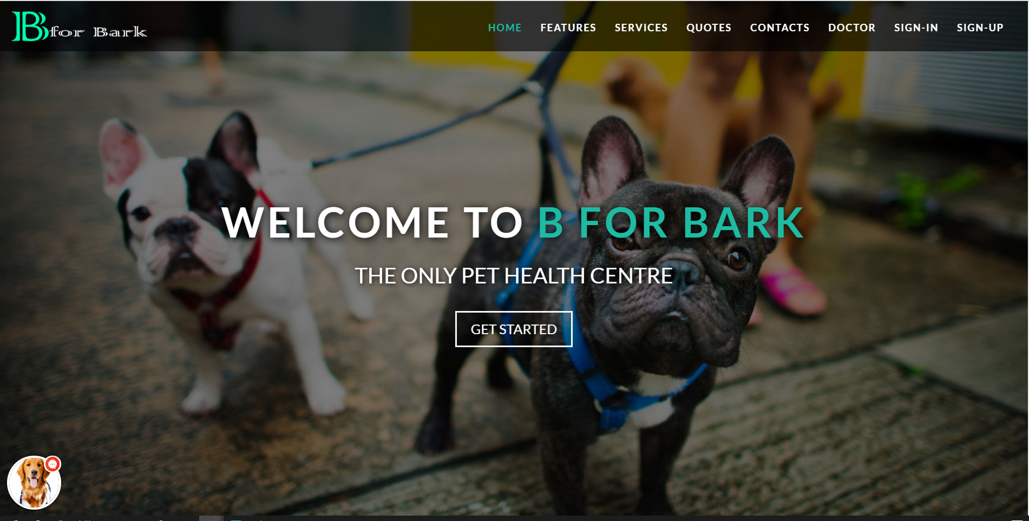

Fig .5.1 index page

## USER REGISTER

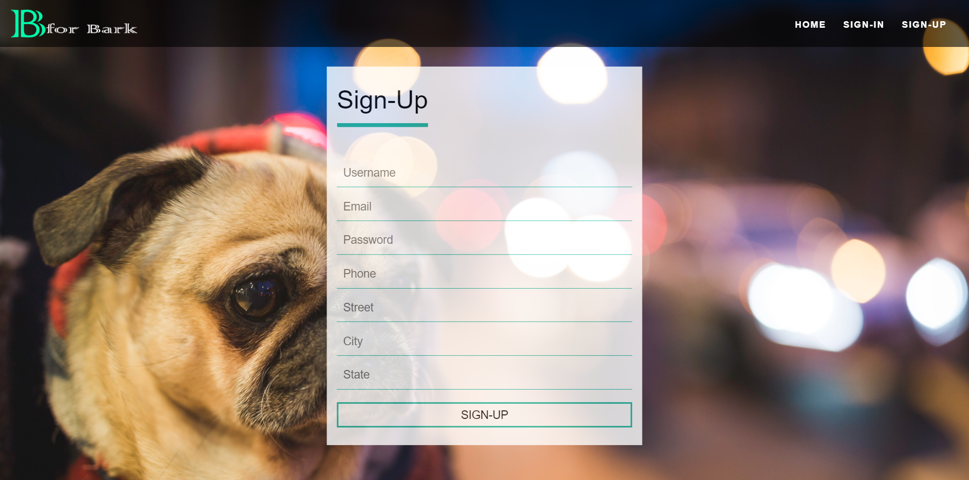

Fig. 5.2 user registration

## USER LOGIN

## 

Fig. 5.3 user login

## SEARCH PAGE

## 

Fig. 5.4 search page

## PET REGISTER

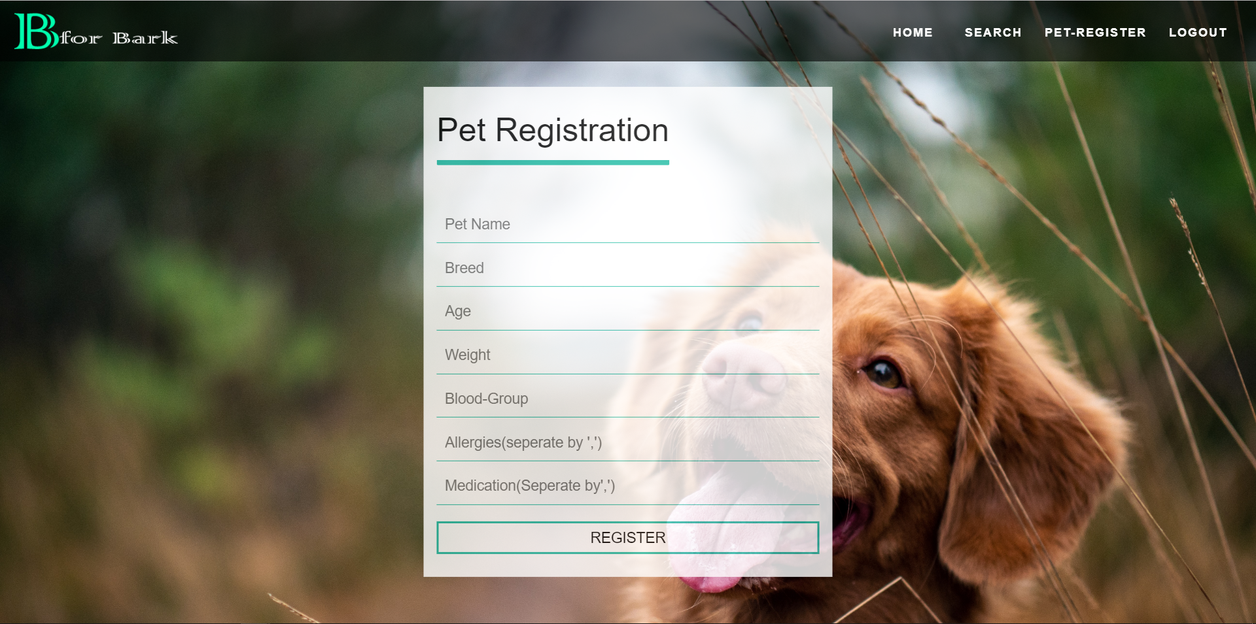

Fig. 5.5 Pet Details

## Health card

## 

Fig. 5.6 Pet-health card

## DOCTORS LOGIN

## 

Fig. 5.7 Doctor login

## DOCTOR HOME PAGE

## 

Fig. 5.8 Doctor home page

# TESTING

## TEST PLAN

### Testing provides an objective, independent view of the software to allow the developers to appreciate and understand the risks of software implementation. Test techniques include, but are not limited to, the process of executing a program or an application with the intent of finding errors, bugs and defects. Software testing, depending on the testing method employed, can be implemented at any time in the development process. Traditionally most of the test effort occurs after the requirements have been defined and the coding process has been completed.

A primary purpose of testing is to detect software failures so that defects may be discovered and corrected. Testing cannot establish that a product functions properly under all conditions but can only establish that it does not function properly under specific conditions. The scope of software testing often includes examination of code as well as execution of that code in various environments and conditions as well as examining all aspects of code: does it do what it is supposed to do and do what it needs to do. Not all software defects are caused by coding errors. One common source of expensive defects is caused by requirement gaps, e.g., unrecognized requirements that result in errors of omission by the program designer. A common source of requirements gaps in non-functional requirements such as testability, scalability, maintainability, usability, performance and security.

A very fundamental problem with software testing is that testing under all combinations of inputs and preconditions (initial state) is not feasible, even with a simple product. This means that the number of defects in a software product can be very large and defects that occur infrequently are difficult to find in testing. More significantly, non- functional dimensions of quality (how it is supposed to be versus what it is supposed to do) usability, scalability, performance, compatibility, reliability can be highly subjective; something that constitutes sufficient value to one person may be intolerable to another. We plan to test our project by various methods of testing. We aim at testing our project and run it under maximum testing combinations possible. By doing this we can check the functionality and the durability of our product. We plan to test our project in three phases, being, unit testing, integration testing and validation testing. Integration

testing is the most detailed and longest process of testing as it consists of the top down approach, a bottom up approach, umbrella approach, black box testing and white box testing.

* 1. **TEST CASES**
     1. **Project home page**

|  |  |  |  |  |
| --- | --- | --- | --- | --- |
| **Test ID** | **Test Scenario** | **Expected Result** | **Observed Result** | **Result** |
| 1 | The pages are loaded with the appropriate controls | The pages and controls are loaded | The components are loaded properly | Pass |
| 2 | Checking different links | The links are redirecting to the appropriate pages | All links worked | Pass |

* + 1. **Login form**

|  |  |  |  |  |
| --- | --- | --- | --- | --- |
| **TEST ID** | **Test Scenario** | **INPUT** | **EXPECTED OUTPUT** | **RESULT** |
| 2.a | Form displayed with all the controls |  | Display the login form with all the controls | PASS |
| 2.b | Enter wrong username | Name (wrong)  Password | Prompt invalid password or name message | PASS |
| 2.c | Enter wrong password | Name  Password (wrong) | Prompt invalid password or name message. | PASS |
| 2.d | Empty details | Blank | Display message to fill all fields | PASS |
| 2.e | Enter correct username and correct password of any of the registered users. | Name  Password | To be directed to user homepage | PASS |
| 2.f | Click on Login Button | Click | Prompt login successfully | PASS |

* + 1. **User Registration**

|  |  |  |  |  |
| --- | --- | --- | --- | --- |
| **TEST ID** | **Test Scenario** | **INPUT** | **EXPECTED OUTPUT** | **RESULT** |
| 3.a | Form displayed with all the controls |  | Display the sign-up form with all the controls | PASS |
| 3.b | Empty details | Blank | Display message to fill all fields | PASS |
| 3.c | Enter existing username | Username(Incorrect), Email, Password, Phone, Street, City, State | Prompt message username already exists | PASS |
| 3.d | Enter incorrect format e-mail | Username, Email(invalid), Password, Phone, Street, City, State | Display message to insert a valid e-mail | PASS |
| 3.e | Enter short or long password length or incorrect format | Username, Email, Password(Invalid), Phone, Street, City, State | Display message to match the requested format and length | PASS |
| 3.f | Enter incorrect length of phone number | Username, Email, Password, Phone(Invalid), Street, City, State | Display message to match the requested format | PASS |
| 3.g | Enter all valid details of user | Username, Email, Password, Phone, Street, City, State | To be directed to the user login page | PASS |
| 3.h | Click on Sign-Up | Click | Prompt successfully registered | PASS |

* + 1. **Forgot password**

|  |  |  |  |  |
| --- | --- | --- | --- | --- |
| **TEST ID** | **Test Scenario** | **INPUT** | **EXPECTED OUTPUT** | **RESULT** |
| 2.a | Form displayed with all the controls |  | Display the login form with all the controls | PASS |
| 2.d | Empty details | Blank | Display message to fill all fields | PASS |
| 2.b | Enter wrong Email | Email(invalid) | Display message user not found | PASS |
| 2.c | Message sending failed | SMTP failure | Display message as an error sending Password Recovery Email | PASS |
| 2.d | Enter valid email | Email | Display message to check users email id. | PASS |

* + 1. **Pet Registration**

|  |  |  |  |  |
| --- | --- | --- | --- | --- |
| **TEST ID** | **Test Scenario** | **INPUT** | **EXPECTED OUTPUT** | **RESULT** |
| 4.a | Form displayed with all the controls |  | Display the pet registration form with all the controls | PASS |
| 4.b | Empty details | Blank | Display message to fill all fields | PASS |
| 4.c | Enter existing Pet Name | Pet name, Breed, Age, Weight, Blood group, Allergies, Medication | Prompt message pet already exists | PASS |
| 4.d | Enter incorrect Age format | Pet name, Breed, Age(string), Weight, Blood group, Allergies, Medication | Display message as not to accept string values | PASS |
| 4.e | Enter incorrect Weight format | Pet name, Breed, Age, Weight(string), Blood group, Allergies, Medication | Display message as not to accept string values | PASS |
| 4.f | Enter incorrect Blood Group format | Pet name, Breed, Age, Weight, Blood Group (invalid), Allergies, Medication | Display message to | PASS |
| 4.g | Enter all valid details of pet | Pet name, Breed, Age, Weight, Blood Group (invalid), Allergies, Medication | To be directed to the user home page | PASS |
| 4.h | Click on Register | Click | Prompt message Pet successfully registered | PASS |

* + 1. **User Homepage**

|  |  |  |  |  |
| --- | --- | --- | --- | --- |
| **Test ID** | **Test Scenario** | **Expected Result** | **Observed Result** | **Result** |
| 5.a | The pages are loaded with the appropriate controls | The pages and controls are loaded | The components are loaded properly | Pass |
| 5.b | Checking different links | The links are redirecting to the appropriate pages | All links worked | Pass |

* + 1. **Search page**

|  |  |  |  |  |
| --- | --- | --- | --- | --- |
| **TEST ID** | **Test Scenario** | **INPUT** | **EXPECTED OUTPUT** | **RESULT** |
| 6.a | Search form displayed with all the controls |  | Display the search form with all the controls | PASS |
| 6.b | Empty details | Blank | Display message to fill the fields | PASS |
| 6.c | Enter Disease Name to search | Disease Name | Description of the disease | PASS |
| 6.d | Enter Symptoms to search | Symptoms | Description of the Symptoms | PASS |

# CONCLUSION

### The developed system has to be built on a large platform for the awareness among the individuals. There is hundred percent efficiency and we can’t assure the system produces the correct output for the given input, there can some error content. So by using many algorithms and techniques we should make sure the system should have the highest efficiency as possible. The remedies which are suggested in the website are homemade and doesn’t cause any side effects. This website is for a Pet Lover who want to make sure the Pet’s Health balanced.

**FUTURE ENHANCEMENT**

* + 1. Use of Google API for the Location details of Doctor
    2. Making the Trend Analysis much efficient in terms of display and Algorithm used
    3. Making the disease and symptom search much more reliable

**REFERENCES**

### [1]. "Introducing Django". The Django Book., 29 July 2018.

[2]. "Django 2.1 released" Django weblog. 2 August 2018.

[3]. “Django documentation” url: “https://docs.djangoproject.com/en/2.1/” [4]. Patrick Dalton, Paul Whitehead, “SQL SERVER BLACK BOOK”

Dream Tech New Delhi, 2005.

[5]. Roger Pressman, “Software Engineering A Practitioner’s Approach”, McGraw-Hill Company, 2001.